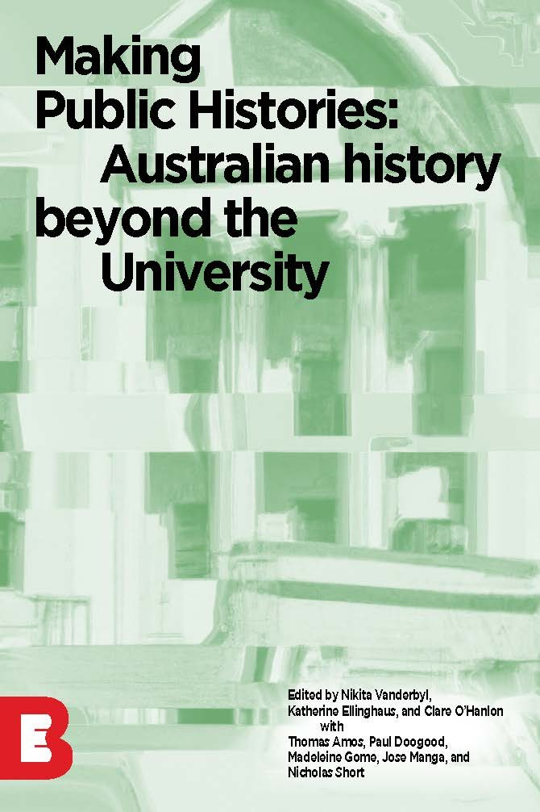

Making Public Histories: Australian History Beyond the University

Making Public Histories: Australian History Beyond the University

Nikita Vanderbyl; Kat Ellinghaus; and Clare O'Hanlon
Thomas Amos; Paul Doogood; Madeleine Gome; Jose Manga; and Nicholas Short
La Trobe eBureau

Making Public Histories: Australian History Beyond the University Copyright © 2023 by La Trobe University is licensed under a Creative Commons Attribution-NonCommercial-ShareAlike 4.0 International License, except where otherwise noted.
This book was published via the Council of Australian University Librarians Open Educational Resources Collective. The online version is available at https://oercollective.caul.edu.au/making-public-histories
Disclaimer
Note that corporate logos and branding are specifically excluded from the Creative Commons Attribution Noncommercial Licence of this work, and may not be reproduced under any circumstances without the express written permission of the copyright holders.
Copyright
Making Public Histories: Australian History Beyond the University by Nikita Vanderbyl, Kat Ellinghaus and Clare O’Hanlon is licensed under a Creative Commons Attribution Noncommercial Share Alike 4.0 Licence by La Trobe University.
Recommended citation: Vanderbyl, N., Ellinghaus, K. & O’Hanlon, C. (2023). Making Public Histories: Australian History Beyond the University. La Trobe University. https://oercollective.caul.edu.au/making-public-histories
Recommended attribution: Making Public Histories: Australian History Beyond the University by Nikita Vanderbyl, Kat Ellinghaus and Clare O’Hanlon is licensed under a Creative Commons Attribution Noncommercial Share Alike4.0 Licence by La Trobe University.
Adapted from image generated by DALL-E 2. Licence to distribute granted by Open AI.

Contents
- Acknowledgement of Country
- Publisher Information
- Accessibility Information
- Acknowledgments
- About the Authors
- Chapter 1: Introduction to Making Public Histories
- Chapter 2: Illustrated essay
- 2.1 James "Jim" Edwin Wiggins: Surviving the Second World War
Thomas Amos
- Chapter 3: Podcasts
- 3.1 Managerialism and the Death of Dissent in Australian Universities
Paul Doogood
- 3.2 The ‘Gweagal’ Shield
Nicholas Short
- Chapter 4: Wikipedia entry
- 4.1 Early 20th Century Calls by First Nations Activists for “Voice” within Australia’s Parliamentary Institutions
Madeleine Gome
- Chapter 5: Exhibition display
- 5.1 Fire Response in Bendigo
Jose Manga
- Chapter 6: Plan your research for publishing public history
- 6.1 Plan your research
- 6.2 Choose and refine your research topic
- 6.3 Navigate Copyright, Creative Commons, and the Continuum of Openness Online
- 6.4 Contextualise collections by considering cultural sensitivity and privacy
- 6.5 Publish your work
- 6.6 Dig deeper in the archives
- 6.7 Conclusion
- Further reading
- Versioning History
- Review Statement

1

Acknowledgement of Country
La Trobe eBureau acknowledges that our publications are produced on the lands of many traditional custodians in Victoria. We recognise their ongoing connection to the land, their centuries of diverse knowledge systems, and value their unique contribution to the University and wider Australian society.
La Trobe University has campuses and undertakes teaching, learning and research activities in the traditional lands of the following people:
- Wurundjeri (Bundoora)
- Wurundjeri / Boonerwrung (City)
- Dja Dja Wurrung (Bendigo)
- Latji Latji / Barkindji (Mildura)
- Dhudhuroa / WayWurru (Wodonga)
- Yorta Yorta / Bangerang (Shepparton)
- Gadigal (Sydney)

2

Publisher Information

LA TROBE EBUREAU
La Trobe University, Melbourne, VIC 3086, Australia
https://library.latrobe.edu.au/ebureau/
Published in Australia by La Trobe eBureau
© La Trobe University 2023
First published 2023
The La Trobe eBureau is one of Australia’s leading open access publishers. Our mission is to create high-quality resources for online and blended subjects, at zero cost to the student. Our published titles have been adopted by academic institutions around the world, granting our authors international recognition.
All our publications are peer reviewed to ensure a high standard of published content.
If you are an instructor using this book we would love to hear from you if you are sing it in your learning and teaching, have suggesting for improvement or any other general enquiries.
Contact us via ebureau@latrobe.edu.au.

Copyright information
Copyright in this work is vested in La Trobe University. Unless otherwise stated, material within this work is licensed under a Creative Commons Attribution-Non Commercial-Share Alike License.

CC BY-NC-SA
Making Public Histories: Australian History Beyond the University
Nikita Vanderbyl; Kat Ellinghaus; and Clare O’Hanlon
ISBN: 978-0-6458388-1-7
DOI: https://doi.org/10.26826/1019

Other information
Formatted by La Trobe eBureau
Cover design by Sebastian Kainey
Cover Image: Adapted from image generated by DALL-E 2. Licence to distribute granted by Open AI.

3

Accessibility Information
We believe that education must be available to everyone which means supporting the creation of free, open, and accessible educational resources. We are actively committed to increasing the accessibility and usability of the textbooks we produce.

Accessibility features of the web version of this resource
The web version of this resource has been designed with accessibility in mind by incorporating the following features:
- It has been optimized for people who use screen-reader technology.
  - all content can be navigated using a keyboard
  - links, headings, and tables are formatted to work with screen readers
  - images have alt tags

- Information is not conveyed by colour alone.

Other file formats available
In addition to the web version, this book is available in a number of file formats including PDF, EPUB (for eReaders), and various editable files. Choose from the selection of available file types from the ‘Download this book’ drop-down menu. This option appears below the book cover image on the eBook’s landing page.

Third-Party Content
In some cases, our open text includes third-party content. In these cases, it is often not possible to ensure accessibility of this content.

Accessibility Improvements
While we strive to ensure that this resource is as accessible and usable as possible, we might not always get it right. We are always looking for ways to make our resources more accessible. If you have problems accessing this resource, please contact eBureau@latrobe.edu.au to let us know so we can fix the issue.
Category | Item
Organising Content | Content is organised under headings and subheadings | Y
Organising Content | Headings and subheadings are used sequentially (e.g. Heading 1, Heading 2, etc.) | Y
Images | Images that convey information include Alternative Text (alt-text) descriptions of the image’s content or function | Y
Images | Graphs, charts, and maps also include contextual or supporting details in the text surrounding the image | N/A
Images | Images, diagrams, or charts do not rely only on colour to convey important information | N/A
Images | Images that are purely decorative contain empty alternative text descriptions. (Descriptive text is unnecessary if the image doesn’t convey contextual content information) | Y
Tables | Tables include column headers, and row headers where appropriate | Y
Tables | Tables include a title or caption | Y
Tables | Tables do not have merged or split cells | Y
Tables | Tables have adequate cell padding | Y
Weblinks | The weblink is meaningful in context, and does not use generic text such as “click here” or “read more” | Y
Weblinks | Externals weblinks open in a new tab. Internal weblink do not open in a new tab. | Y
Weblinks | If a link will open or download a file (like a PDF or Excel file), a textual reference is included in the link information (e.g. ‘[PDF]’). | N/A
Embedded Multimedia | A transcript has been made available for a multimedia resource that includes audio narration or instruction | Y
Embedded Multimedia | Captions of all speech content and relevant non-speech content are included in the multimedia resource that includes audio synchronized with a video presentation | N/A
Embedded Multimedia | Audio descriptions of contextual visuals (graphs, charts, etc.) are included in the multimedia resource | N/A
Formulas | Formulas have been created using MathML | N/A
Formulas | Formulas are images with alternative text descriptions, if MathML is not an option | N/A
Font Size | Font size is 12 point or higher for body text | Y
Font Size | Font size is 9 point for footnotes or endnotes | Y
Font Size | Font size can be zoomed to 200% | N/A
Copyright Note: This accessibility disclaimer is adapted from BCampus’s Accessibility Toolkit, licensed under a Creative Commons Attribution 4.0 International license and University of Southern Queensland’s Enhancing Inclusion, Diversity, Equity and Accessibility (IDEA) in Open Educational Resources (OER) licensed under a Creative Commons Attribution-NonCommercial-ShareAlike 4.0 International License.

4

Acknowledgments
Like all good public history this was a collective effort and we have many people who contributed in different ways to thank.
We would like to thank La Trobe Making History students, past and present, for their care, courage, creativity and community spirit demonstrated through this non-traditional assessment task that we know many of you initially feared doing. The past is in good hands with these future historians.
We would like to thank La Trobe Archaeology and History department colleagues, past and present, especially previous coordinators of the subject, for the collegiality and inspiration. The inspiration for this text came from your incredible work with communities as well as our past students’ work and a desire to share this with the world and help others adopt similar practices.
We would like to thank our peer reviewers Caroline Wallace and Michael McDonnell for their generous feedback that helped us create a stronger book.
We would like to thank the La Trobe eBureau, and in particular Steven Chang and Sebastian Kainey, for letting us do things a little bit differently through experimenting with iterative publishing, and for their constant help, support, and ideas. Clare would also like to thank Georgia Tsioukis from the Library for their ideas and support in shaping/structuring the Publishing public history chapter.
We would like to thank you, our readers, and hope you’re able to find something in here that will help you with your studies and/or future history making practices in the academy, museums, libraries, archives, galleries, historical societies, schools, policy and beyond

5

About the Authors
Nikita Vanderbyl is a writer, researcher, and teacher of history to undergraduate students. She is most interested in the transnational art histories of Aboriginal cultural objects and artworks from the nineteenth century and their relevance to communities today.
Kat Ellinghaus is an Associate Professor of History in the School of Archaeology and History at La Trobe University, where she teaches Australian history. She is of Irish and German descent and is the author of Taking Assimilation to Heart: Marriages of White Women and Indigenous Men in the United States and Australia, 1887-1937 (University of Nebraska Press, 2006) and Blood Will Tell: Native Americans and Assimilation Policy (University of Nebraska Press, 2017). In 2014 she was awarded an Australian Research Council Discovery Project grant to write a history of Aboriginal exemption policies in Australia, a project which continues in collaboration with Judi Wickes, Kella Robinson, Lucinda Aberdeen and Jennifer Jones. In 2019 Kat was lead Chief Investigator on a successful Australian Research Council Discovery project grant which funded a large team to research a project entitled ‘Indigenous mobilities to and through Australia: agency and sovereignties’. In 2020, together with Barry Judd and Richard Broome, she was awarded an Australian Research Council Special Research Initiative Grant to produce a four-volume collection of primary documents entitled ‘Indigenous Australia: A History of Documents 1770-2000’ to be published by Routledge. Kat has researched and written extensively on Indigenous assimilation policies and made an enduring contribution to the field in Australia and internationally. She has presented work to Australian, Canadian and US journals, conferences and publishing houses and has made significant interventions into the history of Indigenous assimilation policy, colonial history, intimacy, gender and racial discourse, and to the task of bringing Australian history to the attention of the international scholarly community and beyond. In the field of Australian settler colonial history, ethical scholarly practices are becoming as, if not more, important than scholarly esteem and expertise. In her most recent work Kat has added a new and important focus: collaborative practice and history writing based on collaboration between Indigenous and non-Indigenous scholars and people which places ethics and community at the highest priority.
Clare O’Hanlon is a librarian who is passionate about encouraging collective reflective practice and making critical and diverse knowledges, theories, and histories accessible within, across and beyond the Galleries, Libraries, Archives and Museum (GLAM) and higher education sectors. Their practice is guided by social justice principles, compassion, courage, and creativity.
Thomas Amosis a Bachelor of Laws (Honours)/Arts graduate from the Wimmera town of St. Arnaud on Dja Dja Wurrung Country. Thomas developed a keen interest in history from a young age, thanks due his late great-grandmother and grandmother being researchers at the local Historical Society. Thomas works as a Peer Learning Advisor at La Trobe University Library and will start History Honours in 2024.
Paul Doogood was born and bred in Dandenong, grew up loving music and literature (and the Richmond Football Club) – and hating high school. He became an apprentice Electrical Linesman with the SEC as a 15-year-old in 1977, but continued to focus on music and literature, playing in a number of loud, weird and angry post-punk bands in the late 70s and early 80s. After his first stint at La Trobe in the late 1980s, he added theatre to the list of things he loves, somehow falling into a career as a puppeteer with Polyglot Puppet Theatre from 1989 through to the early noughties. Stony broke after 20 years in the theatre, he returned to working as a Linesman for 10 years, before essaying another attempt at getting a degree in 2018. He has just graduated and is considering doing Honours next year.
Madeleine Gome is a history and law graduate currently working in the Victorian Government. Her Honours thesis examined the likelihood a referendum on a First Nations’ Voice to parliament would succeed. Madeleine enjoyed completing part of her studies in Norway and Hong Kong. She lives and works on Boon Wurrung and Wurundjeri Country.
Jose Manga was born and raised in Peru where he worked in the cultural tourism sector for sixteen years, before migrating to Australia in 2014. In 2018, Jose started his studies at La Trobe University, graduating in 2021 as a Bachelor of Arts, majoring in History. He lives in Bendigo, Victoria, and currently works at the Bendigo Art Gallery. Jose plans to further his studies in the Museums and Cultural Heritage field. Jose has also been a volunteer firefighter in Peru and Australia for more than twenty years.
Nicholas Short is an English student and shoemaker based in Melbourne. He is attracted to topics related to the Modernist movement and more broader studies in human subjectivity. At the centre of this attraction is an exploration of the definition of ‘meaning’ and how that concept affects human life.

I

Chapter 1: Introduction to Making Public Histories

Nikita Vanderbyl and Kat Ellinghaus
The urge to use history to define and consolidate national identity has never gone away, especially in the political sphere, and especially around moments of national celebration. We can, for example, detect this impulse in Prime Minister John Howard’s statements about the writing of Australian history in his Australia Day speech in 2006. Howard expressed his worries that Australian children were being taught too much about how the beginnings of this nation rested on stolen land and violence against Aboriginal and Torres Strait Islander people, instead of more positive stories about how Australia came to be. ‘In the end,’ Howard, said, ‘young people are at risk of being disinherited from their community if that community lacks the courage and confidence to teach its history. … Let us indeed celebrate our diversity. But we should also affirm the sentiment that propelled our nation to Federation 100 years ago – One People, One Destiny.’ Howard’s determination to affirm ‘One People, One Destiny’ led, in 2007, to the government convening a ‘History Summit’ that tried to promote and control the teaching of history within primary and secondary schools. Since that time the Australia Day national holiday has become the impetus for debates about national identity, settler colonialism and Aboriginal and Torres Strait Islander rights and equality. In 2023, Matthew Bach, the Victorian shadow Minister for education, noted that these conversations were often marked by historical illiteracy, and complained about the sorry state of the history curriculum. ‘Victorian students, across the secondary years, simply aren’t being taught about our history,’ he wrote in the Guardian. Until Australians’ ‘current lack of basic historical knowledge’ was addressed, any discussions about Australia Day would be ‘tedious and divisive’.
But history-making itself is not seen as the answer by everyone. In recent years, there has been growing recognition that history is not a neutral discipline, that its foundations in European knowledge systems ignore other knowledge systems and ways of thinking about the world. Indigenous scholars make this point most powerfully. In 2008 Linda Tuhiwai Smith wrote from a Māori perspective: ‘[T]he sense of history conveyed by [Indigenous epistemologies] … is not the same thing as the discipline of history, and so [she says] our accounts collide, crash into each other […] History is the story of the powerful and how they became powerful, and then how they use their power to keep them in positions in which they can continue to dominate others. It is because of this relationship with power that we have been excluded, marginalized and ‘Othered’.
Victoria Grieves-Williams, a Tasmanian and Warraimay historian, outlines a number of ways in which Aboriginal philosophy incorporates a very different theory and approach. Culturally, Grieves-Williams writes, Aboriginal people do not engage with history as a celebratory or foundational narrative. Indeed, history is not ‘in the past’ but is still very much in the present. She argues that for many Aboriginal people, any difficult history is not forgotten until it is dealt with – and then it is truly left behind. Stories are retained to ensure historical wrongs are addressed and when they are, they are no longer told. People with authority and knowledge lead the resolution of disputes, the wrongs are righted, including through ceremony, and then everyone can move on. The business of the past is then declared to be finished. Grieves argues that Aboriginal and Torres Strait Islander people will not belong to the nation state until their history and their ways of doing history are incorporated into the narrative of the nation and resolved.
Non-Indigenous historians are also grappling with new ways of writing history. Most recently Anna Clark’s Making Australian History has explored how Australian history has been written, revised, and reinterpreted by successive generations of historians. Her focus on key texts extends the scope of primary historical sources to include poetry and Indigenous rock art among others. Motivated by the capacity of history to draw attention to those whose voices have been marginalised, Stuart Macintyre’s Winners and Losers: the pursuit of social justice in Australian history drew attention to the significance of history in public life as a future-oriented discipline whose practitioners seek to make a difference. Connecting history to politics, Paula Hamilton, Paul Ashton and Tanya Evans have recently analysed public history in the context of ‘difficult times’. These authors are interested in what constitutes public history across the world, while also exploring new formats of history-making (including podcasting, Facebook and historical re-enactment). They draw attention to the role of the historian in disruptive times as being necessarily public, whose intention is to influence the present by contributing to public policy and advocacy. Questions arise as to the position of the historian as neutral, complicit, or embedded within the communities about which they write.
Making Public Histories: Australian history beyond the university is based on work produced at La Trobe University in the ‘Making History’ subject. This capstone subject of the History major aims to place students directly into debates about how public histories are, and should be, made. It explores how history manifests in parks, on webpages, in museums, in people’s homes and even on bodies. We start with weeks on the large institutional ways in which the public (broadly defined) encounters history: statues, archives, museums and schools. We then move onto more unofficial, ‘unregulated’, popular forums: such as film and television, Wikipedia, tourist sites, history as generated by communities and engaged in by family historians.
We also think about the many roles the past plays in our lives. How is history utilised by politicians? How is history used to inform debates about our future? And how does the present inform what we look for in the past? Underpinning all this is a question about the ethics of the discipline itself: who makes history? Who tells these stories? And whose stories get left out?
‘Making History’ is shaped by three main themes or questions, which we return to again and again throughout the semester.

1. How can history make a difference?
There is no doubt that history has a huge place in the world. It is there in our everyday lives, in how we understand our family and community, in the news, and in our popular culture. The idea of history constituting a valuable guide for present and future action is an established part of western culture. And the fear of history repeating itself can be seen as directly shaping government policy and societal shifts. If you asked most historians why history is useful, they would probably talk about “making a difference”, about how learning from the mistakes of the past can enable a better future. Historians have an important role as detectives and storytellers and to remind society of things that have happened that may have impact in the present day.
But the intention and ability of history to make a difference is complex and contested, especially when we try to tell a complicated story. There are real dangers in engaging with the past, in unearthing stories that still have power in the present. Whose voices are included, who remains silenced, and who has the authority to speak for whom?

2. What are the ethical and moral obligations that historians have in their role as ‘gatekeepers’ of the past?
The words we write as historians, and how we shape them, and the subjects about which we write – or don’t write – have power, and power beyond the time they were written. It goes without saying that good historians carefully analyse and critique their evidence, they provide and discuss points of view that are contrary to or challenge their ideas about the historical events they are discussing. They attempt to create an historical account which is as true and as objective as is possible from the historian’s particular perspective.
One of the dangers of treating objectivity as the primary way in which we judge ‘good history’ is that historians might go about their business of trying to write well-researched historical narratives with little thought about how their work reaches beyond the academy. They might research a subject simply because it hasn’t been researched before. They might treat archives as treasure troves waiting to be mined, with little thought about how those records got there and whether they contain sensitive information that might hurt people in the present day. They might only rarely reach beyond dusty archival records to engage with the living contemporary communities about whose past they are writing. Indeed, there is an increasing movement for historians to engage more with the communities which they research.

3. How can historical knowledge be co-produced with community input?
Historians work most often from archival sources – it is what sets the discipline of history apart from adjacent disciplines such as sociology, anthropology and political science. While many historians do oral history, and have relationships with the public, and through published research, history remains a discipline that rests on individual research, traditionally in archives and libraries, where the literal requirement for quiet or silence further precludes collaborative working. Historians sift through documentary sources to reconstruct and understand what happened and why, but usually as individuals, as lone scholars, who then publish sole-authored books and journal articles.
‘Making History’ asks students to explore what issues arise when historians do work in collaboration with communities. What happens when historians draw on perspectives that come from outside the archive, and what happens when they share their authority with stakeholders? How do public and community histories challenge and change the way historical research projects are conceived, researched, and written? Can blurring boundaries between historians and communities enable multiple voices to be heard in the historiographical record?
Making Public Histories: Australian history beyond the university presents new and innovative answers to these questions, expressed through fascinating case studies of the past. It is composed of examples of public history research investigating these themes and questions.
This Open Education Resource is divided into two sections, one showcasing student work and one showcasing the work of La Trobe academics. The major assessment in ‘Making History’ entails researching an Australian topic and presenting it in one of four formats for a public audience. Choosing between a Wikipedia page, a podcast, an illustrated essay or an exhibition display proposal, students inhabit the role of a historian and contend with the ethical imperatives this brings. As a third-year capstone subject, critically engaging with the world of history-making beyond the university is an essential focus.
By presenting their work to an audience beyond the history department staff, student-authors have the opportunity to disseminate and celebrate their work. The final week of each semester is dedicated to a mini conference celebrating their research achievements. This culminating experience means the authors in this book have gone from being a student of history to a history-maker.
Through a simulation of the challenges and activities undertaken by historians in many different approaches to history-making, students gain authentic experience which prepares them for their careers after university. ‘Making History’ becomes a space in which to test complex and challenging scenarios, including navigating the copyright and licensing requirements for publicly accessible presentations of their chosen topic, and unpacking the ethical implications of their role as the history-maker. Negotiating the research process, including working through archival materials and institutions, can be testing for every researcher; ‘Making History’ supports students as they gain independence in these tasks and pursue critical enquiry and creativity in their chosen projects. The subject forms a liminal space where students can inhabit the transition from inside to outside university walls, with the support of professional guides.
In the following chapters, student projects showcase the potential of the podcast, the Wikipedia page, the exhibition space and the illustrated essay as vehicles for public history. Ubiquitous and accessible, podcasts have emerged as a prolific field of history consumption. Not only breaking down the barriers between who produces and consumes history, they have also redefined the presentation and dissemination of historical content. Students have drawn from the audio-technician’s bag of tools to craft their audio histories, including thinking about sounds, transitions and narrative devices often previously reserved for the dramatic and fictional genres.
Wikipedia’s fortunes as a less-than-honourable reference in undergraduate assignments are put under the spotlight by projects in Making Public Histories. Students adopting this format must follow Wikipedia’s own rules – of engagement, referencing and accessibility of sources – which in turn provokes students to think differently about questions of plagiarism. Embracing the unique task of writing (potentially) for the entire English-speaking corner of the Internet, students explore knowledge-making in the public domain in ways that no other assessment format can allow.
Using objects to access the past enables a form of history-making that connects students with all that Galleries, Libraries, Archives and Museums (or GLAM) organisations have to offer. Utilising the exhibition format requires students to construct narratives in three dimensions and to understand how different audiences from differing backgrounds and abilities might encounter their displays. Rather than requiring a physical display, students prepare a proposal for an exhibition. This has the added appeal of allowing students to situate disparately located objects together in a hypothetical dialogue.
Essays are a staple of academic writing; however, the illustrated essay requires the careful incorporation of images and multi-media material. This takes the format into an arena where readers might also find investigative long-form journalism with interactive videos, images, or sound included. Projects utilising archival material are also well suited to this format and complement an immersive reading experience.
The ’Making History’ subject has evolved since its inception in 2015 and its current form builds upon the work of previous subject coordinators Adrian Jones, Ruth Ford, Roland Burke and Ingrid Sykes. From its very earliest inception in 2005 the subject focussed on giving students who majored in history the chance to reflect on their discipline, and to experience discussions and classes focussed less on content and more on developing the skills they wanted to develop. As the first coordinator, Adrian Jones, describes it, students were encouraged to “own” the role and title of “historian”. Video and illustrated essays formed the primary assessments from 2015 to 2019. Much of this work has been archived on a dedicated internal student blog. In 2020 the subject took on its current form and the desire to continue showcasing the work of students persisted until, with the assistance of the La Trobe Library and eBureau, this publication was born.
A sharper focus on licensing and audience accessibility emerged during the ‘lockdown’ research period of the pandemic, continuing through the era of opening up and ‘living with the virus’ in 2022/2023. Students and researchers alike confronted the challenges of completing research projects with limited access to archives until relatively recently. Clare O’Hanlon’s chapter ‘Plan your research for publishing public history’ takes its inspiration from these recent developments. It is an instructive ‘how to’ for researching and disseminating history publicly, drawing attention to important ethical considerations, and giving practical examples. As access has been restored, we are forced to think anew about when and how historians enter the archive and who their audiences are when they emerge. You, dear reader, might be a student or an amateur historian, you might be based inside a university or an historical society. In all cases you are accessing this text as a piece of open research, made available under license that allows the work to be shared, no profits are to be made from it and appropriate attribution to the authors must be made. It is not behind a paywall or shelved in a library, instead it can be read by anyone with the correct URL.
We believe the historical profession is at an exciting time, a time when we are questioning current and past practices and daring to offer new ways of thinking and working. ‘Making History’ asks students to be part of that change, and we are thrilled to be able to share the work of a new generation of historians in this publication.

The full speech can be found here:
, accessed 26 January 2023.

Matthew Bach, ‘Change the Date?’, Guardian, 24 January 2023,
, accessed 26 January 2023.

Victoria Grieves-Williams, ‘Makarrata: The Aboriginal healing process we should all know about,’ 9 July 2019,
, accessed 26 January 2023.

Pente, Elizabeth, Paul Ward, Milton Brown, and Hardeep Sahota. "The Co-Production of Historical Knowledge: Implications for the History of Identities." Identity Papers: A Journal of British and Irish Studies 1, no. 1 (2015): 34.
.

I

Chapter 2: Illustrated essay
Essays are a staple of academic writing; however, the illustrated essay requires the careful incorporation of images and multi-media material. This takes the format into an arena where readers might also find investigative long-form journalism with interactive videos, images, or sound included. Projects utilising archival material are also well suited to this format and complement an immersive reading experience.
In this chapter you will find the following digital creations by student authors that exemplify the core qualities of this particular medium:
2.1 James “Jim” Edwin Wiggins: Surviving the Second World War

1

2.1 James "Jim" Edwin Wiggins: Surviving the Second World War
Thomas Amos

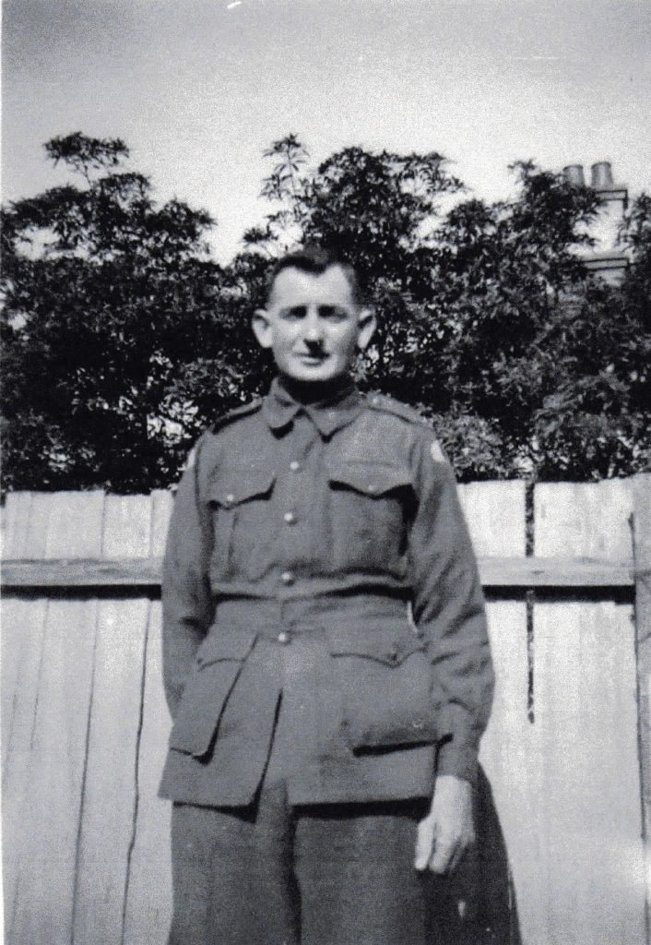

The Second World War was one of the significant periods in Australia’s history, as its victory brought a rapid period of economic prosperity and a more independent outlook. However, over 30,000 Australians would become prisoners of war. This essay will discuss the wartime experience of one of these prisoners, my great-great-grandfather James (‘Jim’) Edwin Wiggins. Many of his stories can be told through the items he brought home. These items have remained in the family for over four generations, alongside the stories which make them significant. Therefore, this essay will give a more detailed background and metadata to the stories and the items which make Jim’s wartime experience. After struggling to find a stable job during the Great Depression, Jim would enlist to serve his country and receive a chance of regular employment. Jim would be part of the Battle of Singapore, where he became a Japanese prisoner of war (‘POW’) and spent a year in Changi. After consistent sickness in Changi, Jim would become part of “G Force” and was sent to Japan. He would spend the rest of the Second World War in Osaka and Takefu. After coming home, Jim would never fully come to terms with this experience.
The stories that make up this essay are a product of an inherited legacy, as I become the third generation in my family to write about them.
Many of these stories were saved by my great-grandmother, Jessie Cameron (nee Wiggins), who received them through her brother. Jim would usually only discuss his wartime experiences with his male friends and sons. Thus, this was a clear rejection of Jim seeking control over his story and the transmission of social emotions to his family. Moreover, the items behind Jim’s wartime experience would fall into what Buchanan calls “ambient knowledge”. While some of the items can highlight the shared experiences of Japanese POWs, most of them are constructed through Jim’s experience and family knowledge. Moreover, all of Jim’s items have precise metadata that I have encountered. The metadata collected in the past has mainly been related to Jim’s stories and how they survived. The role I play with this essay is to create better metadata by adding thicker, academic-based descriptions to Jim’s item and his story. Therefore, this metadata can provide a more accurate foundation for future research projects into Jim’s life.
On 18 January 1903, Jim was born on his parent’s farm in Korong Vale. Soon after, they moved to the small farming district of Emu, near Bealiba. He would continue to live in Emu until 1927 when he and his young family moved to Maffra. During his time working as a seasonal lumberjack in Gippsland, he and his family would feel the impacts of the Great Depression. For example, his family lived mainly off the vegetables he grew with occasional rabbit and fish. They would move to Shepparton in 1935, living in a two-roomed tent. Jim would work as a fruit picker and channel digging on sustenance. They would move back to St. Arnaud in 1936, but Jim’s struggle to find work continued. Jim would enlist in the Australia Imperial Force (‘AIF’) on 28 June 1940. There were two main reasons why Jim enlisted: he thought it was the right thing to do for Australia, and he wanted a chance at stable employment. The “king and country” sentiment was common in mid-1940, as the Battle of Britain was beginning. The highest peak of AIF enlistment occurred during this time. Moreover, Jessie also noted that “six shillings and day and … [a family] allowance” got many men to enlist.
However, Jim would not fit the “average Australian soldier” aged in his 20s from an industrial or white-collar background described by Grant and James. He was 37 and from a rural background with five children.

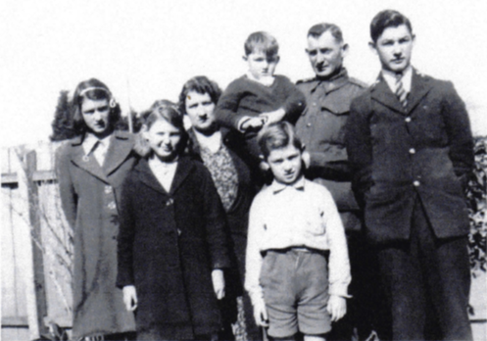

Figure 2 is Jim’s last photo with his children before going overseas. Jessie Cameron hated this photo because it shows her and her siblings’ “sad faces”.
Jim would sail from Fremantle on 8 August 1941, arriving in Singapore a week later. Jim was a member of the 2/29 Battalion, and their first barracks were in the suburb of Katong. Soon after, he would be hospitalised with mumps. After being discharged, he joined the 27th Brigade because the 2/29 had moved into British Malaya. Jim would spend the next three months in the Johore state of British Malaya, participating in the Malayan Campaign. In January, the 27th Bridge would take part in the Battle of Singapore. The fall of Singapore on 15 February 1942 would have significant adverse effects on Australia, as the war would come closer to home.[33] For Jim, the British surrender would mean he would become one of the 22,000 Australians to become Japanese POWs between January and March 1942.

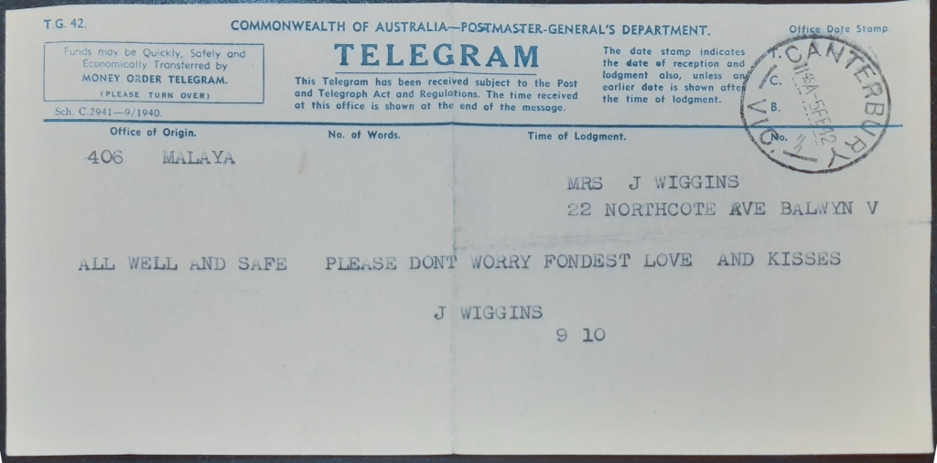

Figure 3 is Jim’s last form of communication with his family before becoming a Japanese POW. The next time Jim’s family would hear from him was around six months later.
Furthermore, Jim would be marched to the Changi POW Prison two days later. It would serve as a transit camp where prisoners were housed until being moved on as forced labours in Burma, Borneo, and Japan. Hygiene and sanitation would become a massive concern in Changi. Tropical diseases would be a constant threat due to Singapore’s climate, causing malaria and cholera outbreaks. Jim would suffer dysentery and Dengue fever during his time in Changi, and his weight would also drop from 76kg to 38kg. Many of the items Jim kept during his wartime experience tell us about his time in Changi:



Figure 4 shows the spoon he would eat rice with throughout his wartime experience. POWs would struggle with a severe lack of food and malnutrition caused by an imbalance, rice-based diet. Small groups of prisoners would scrounge food and share it, as rice rations were too small and left POWs hungry.

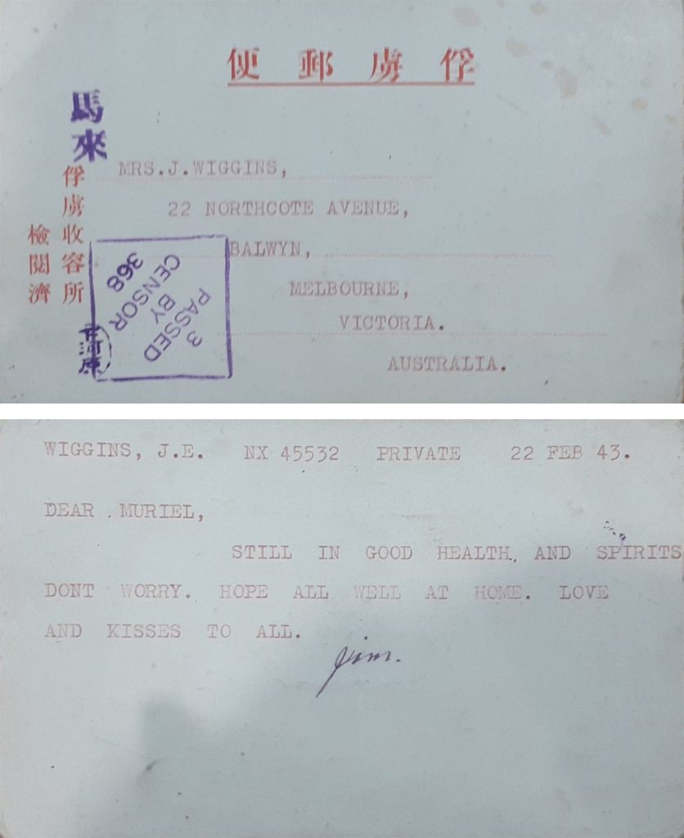

Figure 5 shows one of the postcards he sent home to his family from Changi. The postcards were strictly restricted to only 24 words, and the Japanese gave detailed instructions on what the POWs could and could not write. However, the response from the POWs was highly positive as the need for communication with home was long desired.

In 1943, Edward “Weary” Dunlop decided Jim would be sent to Japan as a cooler climate may give him a better chance of survival.

This most likely occurred in January when Dunlop was organising his forces who would become forced labourers on the Burma-Thailand Railroad. Thus, Jim would become part of “G Force”, who would be sent to Japan on 25 April 1943. Many G Force POWs were mainly sick, disabled, or hospital and maintenance staff. G Force would be transported to Japan on a one-month voyage on a “hell-ship”. Onboard these ships, POWs were forced into overcrowded holds and suffered further severe malnutrition and disease due to starvation, dehydration, and inadequate hygiene. The hell-ships would also be where many POWs first interacted with Japanese soldiers, as Australian and British officers were still responsible for enforcing discipline in Changi. Jim’s movement over the next two years is based on primary sources. Jim would be stationed at the Taisho POW camp in Osaka. He most likely worked in the Osaka Ironworks until March 1944, when he became too weak to walk. He then began working around the camp, repairing boots for Japanese officers and gardening.

Figure 6: Pages from Jim’s service book showing Japanese transitions. Source: VX45532 James Edwin Wiggins AIF Service Book [notebook] (c. 1940-1945). Used under CC-BY-NC-ND.

Figure 6 shows Japanese translations of commands from his service book. The Japanese saw to reinforce the POW position during their inactions, seeing its use as enforcing the Imperial Japanese Army (“IJA”) wishes.
However, the conditions of POW camps in Japan would vary significantly. Jim did have his thumbs flattened with a hammer once by an IJA guard and had lash marks on his back from beating. The POWs received three small bowls of rice each day in Taisho. Jim would steal small pumpkins from the garden when working in the camp. He also climbed a wall from his boot-mending hut, across the ceiling of the guard’s room, to scrounge rice from the connected storeroom. Although only approximately four Australian POWs died as members of G Force, many were still very sick. POWs were marched to and from the Ironworks each day, around 2.4km from the camp. They would work 10-hour shifts, having a rest day every two weeks. When Jim became too weak to walk, he had to be supported by the workers and guards back to the camp. Moreover, Jim recorded interactions with Japanese civilians were positive, holding no hatred towards them. One of Jim’s stories was about an older man putting a newspaper in the wire of the prison fence each day.
By May 1945, Jim was moved to Takefu POW camp, like many of the prisoners in Taisho. Part of the reason prisoners speculated for this move was that Osaka had been becoming a target of American bombing raids. On 15 August 1945, Japan surrendered to the Allies, ending the war. Jim’s activities after leaving the camp are not entirely known, but he was in Yokohama in early September before travelling to Manilla. However, several of Jim’s items do tell stories from this time:

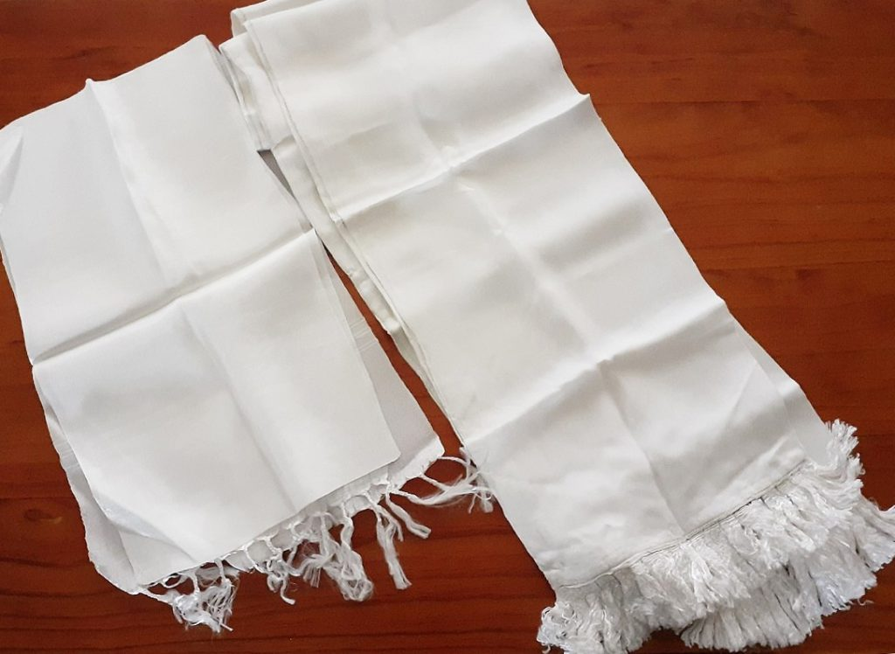

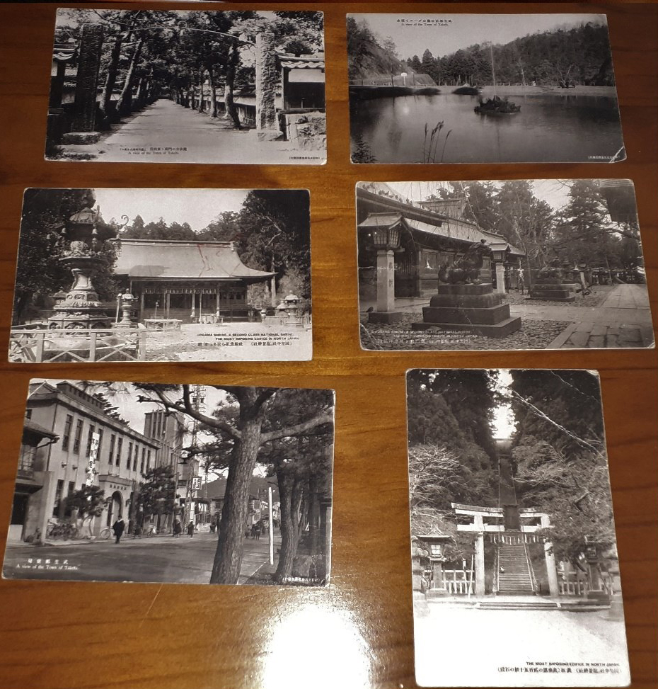

Figure 7 shows scarves made out of parachute silk and figure 8 shows a collection of postcards from Takefu. The postcards were picked up as souvenirs when he was allowed out of the camp. The parachute silk scarves were in American food supply drops, which started on 28 August. These supplies allowed Jim to gain 12kg within the first month since the ending of the war and were also regularly shared with Japanese civilians.

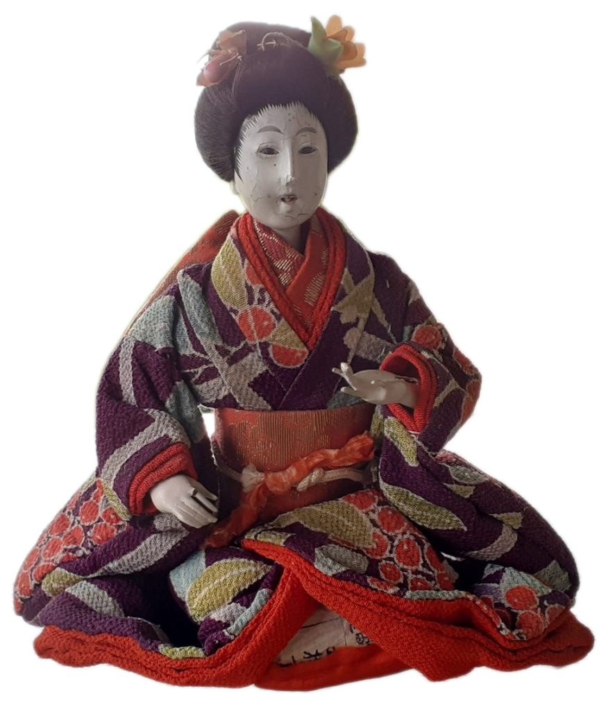

Figure 9 shows another souvenir Jim got in Japan, a doll. The story surrounding this was one of Jim’s friends, who was too weak to go out, started crying when he saw it because he could not get any souvenirs. Therefore, Jim decided to give him the dog connected to the doll.
Additionally, Jim was discharged from the AIF on 3 December 1945, returning to Australia on the HMS Formidable. Jim had regained his weight to 88kg by the time he returned. When receiving food on the HMS Formidable, he would jump back in line to receive seconds. After the war, Jim worked with his sons in Melbourne for Victorian Railways before moving back to St. Arnaud. Like many, Jim would feel the effects of wartime experience for the rest of his life. One incident was when multiple planes were surveying over St. Arnaud; Jim had nightmares and would go to the ground when they flew over. This suggests he was suffering some form of trauma, which the development of its understanding would occur over the post-war years. Jim rarely talked about his wartime experience, only talking about them to his friends and sons.
Jim died on 8 December 1967 at the age of 64 from heart failure. Thus, he would not live to see the significant developments towards the attitudes of former POWs. Firstly, there was growing international attention toward previous human rights violations starting from the 1970s. And secondly, post-traumatic stress disorder was officially recognised as a psychiatric category in 1980.
To conclude, my great-great-grandfather, James (“Jim”) Edwin Wiggins, was one of the many Australians that became a Japanese prisoner of war during the Second World War. His items and stories from his wartime experience have been passed down through four generations of my family. This essay gives some more described context and metadata so that future projects can have a more accurate foundation into Jim’s life. Like many, Jim struggle to find stable employment during the Great Depression. Enlisting gave Jim a chance at regular employment and allowed him to support his country. He fought in British Malaya and Singapore before being captured as a POW after the fall of Singapore. Jim would spend a year in Changi and suffer sickness and serve malnutrition. In 1943, he was sent to Japan on a hell ship as part of G Force. Jim would spend the rest of his wartime experience in Osaka and Takefu. He would work in factories before becoming so weak that he could not walk without support. Jim would come home and resume his ordinary life but would feel the effects of his wartime experience for the rest of his life. Unfortunately, he died before many realised the struggles Japanese POWs faced when returning home.

Reflection
My essay discussed my great-great-grandfather, James (‘Jim’) Edwin Wiggins, experience as a Japanese Prisoner of War (POW) during the Second World War. This essay is structured around items kept from his experience, such as letters and photographs, letting their stories produce scholarly analysis. Using Rachel Buchanan’s article, The Iran Album (1974): Some Sleeve Notes, as the template, the essay gives more detailed metadata to these items to show how archival material can be used in writing family or personal history. In this context, the metadata produced by my essay is academically based, adding to the existing family’s knowledge of Jim’s experience. That article became my primary influence because the initial idea was to use this project to show off these items while also telling Jim’s story.
The critical concept of Jim’s story is survival. Jim suffered severe sickness and hunger while interned as a Japanese POW. The survival concept is also relevant to the items. Many of their stories would not have survived if my great-grandmother, Jessie Cameron, had not saved them from Jim’s social control of his emotions. I also wanted to challenge Australian Second World War historiography. The average Australian Second World War soldier is often seen as a man in their 20s from an industrial, urban background. However, Jim does not fit this mould. He was 37 at the time of his enlistment and came from a rural background. I saw Jim’s story as a unique perspective from one of more than 30,000 Australians who found themselves Japanese POWs.
I chose the illustrated essay format because it was the best format to explain Jim’s life story, compared to a museum display. Although, I found it hard initially to give the essay’s narrative over the items because there were many other topics I wanted to discuss. For me, the hardest to leave out of the final version was his experiences from the Great Depression, which also connected to the survival concept very well. I also found it hard to reflect on the historian’s role fully. I understood I was adding academic-based information to stories recorded as personal accounts. However, I could not figure out how to express this aim within the essay. I realised afterwards this essay was an excellent example of the academic-based transformation family history has seen. This is because I used the material made by Jesse and Nan (Jan Amos) in a hobby-based pursuit and added academic research.
As gatekeepers of history, we intentionally make political editorial decisions whenever we discuss wars, mostly without realising. During this project, I did make clear political editing decisions. I wanted to avoid any sensitivity as the relationship between Australia and Japan has changed significantly since the end of the Second World War. I relied heavily on the notes Jessie wrote about the items, which focused on stories of torture and war crimes performed by the Imperial Japanese Army (IJA). The only stories of this nature which made it into the final essay were those I could back up with references from other primary accounts from Jim’s battalion and work parties. I also wanted to reinforce that Jim did not hold any hatred towards the Japanese, as many fellow POWs did, for the crimes committed against them by the IJA.

About the Author
Thomas Amos
Thomas Amos is a Bachelor of Laws (Honours)/Arts graduate from the Wimmera town of St. Arnaud on Dja Dja Wurrung Country. Thomas developed a keen interest in history from a young age, thanks due his late great-grandmother and grandmother being researchers at the local Historical Society. Thomas works as a Peer Learning Advisor at La Trobe University Library and will start History Honours in 2024.

II

Chapter 3: Podcasts
Ubiquitous and accessible, podcasts have emerged as a prolific field of history consumption. Not only breaking down the barriers between who produces and consumes history, they have also redefined the presentation and dissemination of historical content. Students have drawn from the audio-technician’s bag of tools to craft their audio histories, including thinking about sounds, transitions and narrative devices often previously reserved for the dramatic and fictional genres.
In this chapter you will find the following digital creations by student authors that exemplify the core qualities of this particular medium:
3.1 Managerialism and the Death of Dissent in Australian Universities
3.2 The ‘Gweagal’ Shield

2

3.1 Managerialism and the Death of Dissent in Australian Universities
Paul Doogood
Listen to the Managerialism and the Death of Dissent in Australian Universities podcast.

One or more interactive elements has been excluded from this version of the text. You can view them online here: https://oercollective.caul.edu.au/making-public-histories/?p=322#audio-322-1
View the podcast transcript.

Reflection
The podcast I produced for the Making History project compares the response to neoliberal higher education reforms introduced in Australia in the late 1980s with reforms along similar lines handed down in 2020. I was drawn to the topic as I happened to be studying at La Trobe University on both occasions and as such witnessed the reception of each of these initiatives first-hand.
I first attended La Trobe in the late 1980s, just as the Hawke government Education Minister, John Dawkins, began reforming the sector in response to the neoliberal global economic dispensation established during that decade under the leadership of UK Prime Minister, Margaret Thatcher, and US President, Ronald Reagan. Thousands of La Trobe students offered up as militant a response to the proposed reforms as any student body in Australia. I threw myself into the fight to the extent I soon became a leading activist on-campus. A protest group I helped found occupied the University Administration Centre for 11 days, staged countless protests, and filled the student newspaper, Rabelais, with articles railing against the changes.
In part due to the fact I was so consumed by the protest movement, I failed to complete my degree, eventually returning to La Trobe in 2018 to make a second attempt, just in time for the introduction of then Education Minister Dan Tehan’s “Job Ready” reforms! As the name suggests, the Tehan reforms furthered the process of aligning the Higher Education sector with the demands of industry begun by Dawkins in 1987. However, unlike in the case of the Dawkins reforms, they were met with little resistance. I set out to gain some idea why, and discovered the answer can be found, at least in part, in the very nature of the earlier reforms – specifically, the way in which neoliberal principles were embedded through changes to managerial practices at the institutional level.
Where the management of Australian universities prior to the Dawkins reforms was collegial and inclusive, the new dispensation introduced a managerial model which saw a small, highly-paid executive elite established at each institution and set not just above, but apart from, the academic and other administrative staff. These core groups have close ties to government and industry and are more responsive to their wants and needs than to those of the staff and students they notionally serve. This leadership model, dubbed “managerialism”, is fundamental to the way neoliberalism operates, and, I would argue, its entrenchment at the institutional level is central to the progressive paralysis that pertains today.
In contrast to the situation pertaining until the 1980s, narrowly-focused economic imperatives as determined by government and industry are now so central to the structure and management of all manner of organisations, including universities, it is almost impossible to mount any argument – let alone a protest movement – that does not first concede their primacy. As such, resistance to policy changes is reduced to focusing on issues at the margins, with any small wins soon swept aside by the next round of reforms. Unless and until progressive resistance to the economic and social depredations wrought by neoliberalism focuses on the way it holds sway at the institutional coalface, it will continue to flounder.
I chose to present my arguments in the form of a podcast primarily because I didn’t want to pretend to be a neutral observer. I learned from the Making History course that acknowledging that you approach your topic from a particular perspective is preferable to pretending to a level of objectivity you cannot attain. As outlined above, I actively opposed the education reforms introduced in 1987. I also produced a submission on behalf of the Student Union in 2020 urging the La Trobe University executive to put up more of a fight in response to the Tehan reforms. I have consistently opposed and campaigned against the neoliberal model of the university, and in producing this history felt it was necessary to make clear I am presenting the events from the point of view of an activist, not just an observer. The podcast is a story-teller’s medium, with the tone and temper of the delivery making more obvious the position of the person delivering it, adding a layer of meaning not so easily conveyed with mere words on a page. As such it lends itself well to the presentation of history from the participant’s point of view.
In terms of the presenting style I adopted, I must confess to being heavily influenced by Marc Fennell’s “Stuff the British Stole” podcast. Fennell has a finely-tuned sense of the ludicrous, which he deftly employs to keep his audience engaged at times when the often darkly serious subject matter he presents might otherwise see some listeners switching off in despair. While I don’t pretend to have anything like his broadcasting chops, I too can see the funny side of human folly, and as such thought I could do worse than take a lead from his playful presentation style. One rather obvious way in which I emulated Fennell was in teasing my listeners with an unexplained acronym during my introduction, before eventually working my way back to revealing what it stood for in advance of my conclusion. An utterly shameless strategy, no doubt, but an effective way of maintaining audience interest. The lesson I took from Fennell was that while remaining true to your subject matter ought to be the historian’s primary concern in producing a podcast, your best efforts are wasted if the manner in which you present it causes your audience to lose interest.
February 2023, Vichy, France

About the Author
Paul Doogood
Paul Doogood was born and bred in Dandenong, grew up loving music and literature (and the Richmond Football Club) – and hating high school. He became an apprentice Electrical Linesman with the SEC as a 15-year-old in 1977, but continued to focus on music and literature, playing in a number of loud, weird and angry post-punk bands in the late 70s and early 80s. After his first stint at La Trobe in the late 1980s, he added theatre to the list of things he loves, somehow falling into a career as a puppeteer with Polyglot Puppet Theatre from 1989 through to the early noughties. Stony broke after 20 years in the theatre, he returned to working as a Linesman for 10 years, before essaying another attempt at getting a degree in 2018. He has just graduated and is considering doing Honours next year.

3

3.2 The ‘Gweagal’ Shield
Nicholas Short

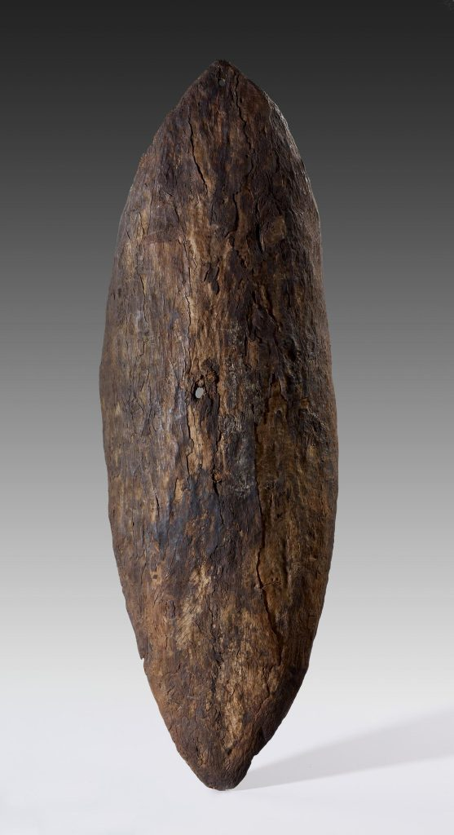

Listen to The ‘Gweagal’ Shield podcast.

One or more interactive elements has been excluded from this version of the text. You can view them online here: https://oercollective.caul.edu.au/making-public-histories/?p=341#audio-341-1
View the podcast transcript.

Reflection
For my research project I created a historical narrative podcast on the Gweagal shield. The Gweagal shield was or is a wooden shield that Captain James Cook’s landing party stole from a group of Gweagal men when they first landed at Botany Bay in 1770. And it was taken back to England and was lost track of. But in 1978 the British Museum found an Aboriginal shield forgotten in their collection that they assumed to be this shield, and displayed it as such. And it was displayed like that until the late 2010s, when some historians traced the record of the Gweagal shield and realised that the shield in the British Museum was very likely not the same one. And so the location of the actual Gweagal shield is unknown and the origin of the shield in the British Museum is a mystery.
I wanted to create a podcast because with an auditory medium you can play with tension through time really effectively. Podcast scripts are a form of storytelling: there’s a narrative that you’re leading the listener through. But you have to make sure you’re always discussing historical information or methods while still being interesting, which can be difficult. You’re always grappling with tension to keep the listener interested, but also providing information to keep them satisfied. And that’s just a matter of making sure your editing is really focused. I had a script that I continually tightened again and again. I opened the podcast with a recreation of that original Botany Bay landing to build interest, and jumped off from there.
I chose to discuss the relationship physical objects have with history, and how those two relationships feed into one another. When we see a historical object—usually in a museum—it feeds our understanding of the time period that object comes from. But also, the histories we learn about objects feed into the objects themselves. It’s this two-way street of presence and interpretation. But when you have an object with an assumed history that is then proven to be misplaced or just outright wrong—the historical value dissipates, but there’s also an unnerving epistemological break that occurs—this whole structure of understanding collapses completely and all that’s left is the object. And that’s where claims from historical guardians such as museums cause trouble like the British Museum’s example: there’s an institutional damage that occurs from that unsettling of trust, but also an unsettling of trust with established histories themselves.
This unknown shield has the same effect the Gweagal shield would have if it was that object, but its anonymity allows it to be viewed as one small part of a very complex and a very old structure rather than this lone object it was previously that was overshadowed by a single event. History becomes more of a tool for recognising narrative, it becomes more useful that way. I wanted to capture that feeling in the podcast, I wanted the ending to be a recognition that there are historical narratives happening everywhere. It’s always complex and half-missing and unclear. And usually the straight-forward, obvious grand narratives you read are oversimplified or hold some hidden agenda in them. History is always a lot more complex.
January 2023

About the Author
Nicholas Short
Nicholas Short is an English student and shoemaker based in Melbourne. He is attracted to topics related to the Modernist movement and more broader studies in human subjectivity. At the centre of this attraction is an exploration of the definition of ‘meaning’ and how that concept affects human life.

III

Chapter 4: Wikipedia entry
Wikipedia’s fortunes as a less-than-honourable reference in undergraduate assignments are put under the spotlight by projects in Making Public Histories. Students adopting this format must follow Wikipedia’s own rules – of engagement, referencing and accessibility of sources – which in turn provokes students to think differently about questions of plagiarism. Embracing the unique task of writing (potentially) for the entire English-speaking corner of the Internet, students explore knowledge-making in the public domain in ways that no other assessment format can allow.
In this chapter you will find the following digital creations by student authors that exemplify the core qualities of this particular medium:
4.1 Early 20th Century Calls by First Nations Activists for “Voice” within Australia’s Parliamentary Institutions

4

4.1 Early 20th Century Calls by First Nations Activists for “Voice” within Australia’s Parliamentary Institutions
Madeleine Gome
Content Note: This article contains images of Aboriginal people who have died. It includes offensive language when quoting from historical sources.

Aboriginal Voice to Parliament (1900-1950)
The Voice to Parliament is a proposal to establish a body of Aboriginal peoples to advise the Australian Government on matters concerning Aboriginal people and issues. In 2017, the Uluru Statement from the Heart and Referendum Council Final Report called for the implementation of a new representative body. The concept of Indigenous representation in Parliament is not new. Aboriginal activists have sought such action since the early 20th Century.

Background

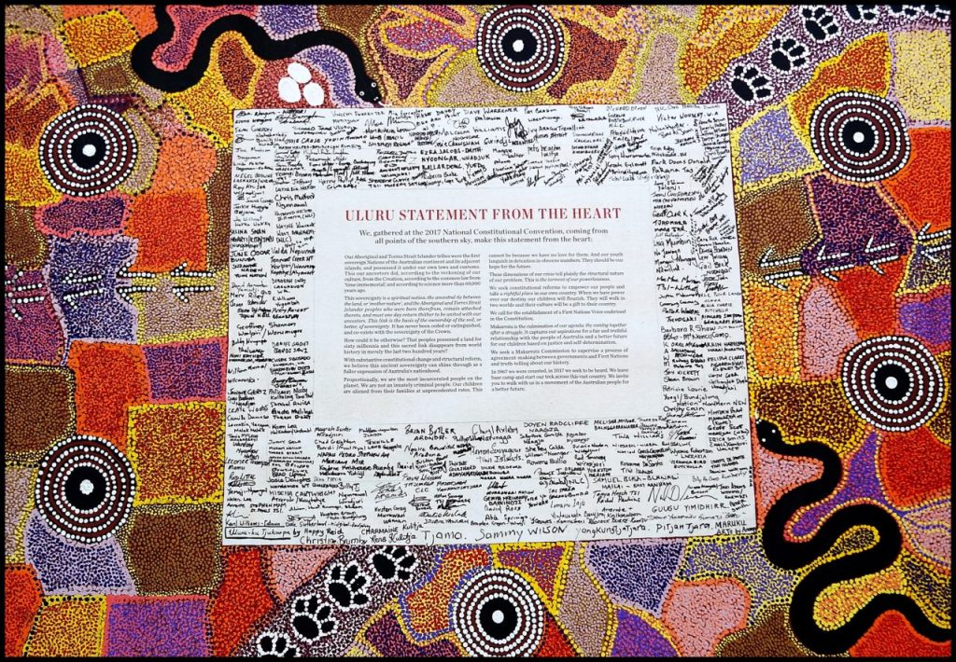

Activism by Aboriginal people has occurred since Britain first settled Australia. The first politically active Aboriginal organisation was established under the leadership of Fred Maynard in 1924. Other bodies such as the Australian Aborigines’ League and Aboriginal Progressive Association soon followed.Indigenous activism in the 1920s and 1930s centred on the need for Aboriginal affairs to be federally administered, and opposition to the oppressive powers of state Protection Boards which implemented policies of child removal and dispossession of land. Activists such as Bill Ferguson, Faith Bandler, Jack Patten, Pearl Gibbs and William Cooper campaigned for equal citizenship rights.Many Aboriginal leaders of the early 1900s also sought an Indigenous voice to parliament. While the Uluru Statement from the Heart has reignited public debate about a representative body, the proposal stems from a hundred-year history. Although the exact form and functions of such representation differed between activists and across time, the consistent message has been a call for empowerment and self-determination of Aboriginal affairs.

1920s

Fred Maynard

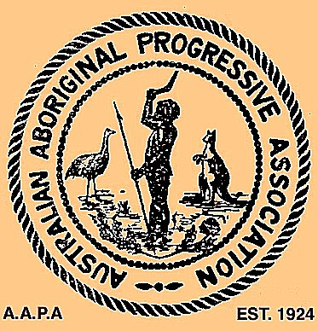

Maynard was a Worimi man who founded the first Aboriginal political activist organisation, the Australian Aboriginal Progressive Association (AAPA), in 1924. The group’s activism focused on the forced removal of Aboriginal people from reserve land in New South Wales, and the removal of Aboriginal children from their families by the New South Wales Aboriginal Protection Board. The organisation also led the call for Indigenous people to have determination over Aboriginal Affairs. In 1927 Maynard stated:

Our request to supervise our own affairs is no innovation. The Catholic people in our country possess the right to control their own schools and homes, and take pride in the fact that they possess this privilege. The Chinese, Greeks, Jews and Lutherans are similarly favoured and our people are entitled to precisely the same conditions
–Fred Maynard, Letter to the Premier, 1927

1930s

Shadrach James
Shadrach Livingstone James was a Yorta Yorta man, the son of renowned teacher and activist Thomas Shadrach James. He was a law student, lobbyist, legal advisor, activist and central figure of the Aborigines Progressive Association of Victoria. James was a prolific campaigner, renowned for his remarkable handwriting. In one 1930 article written for the Herald, James proposed ‘a native representative in Federal Parliament’. This is the first known example of an Australian newspaper publishing a call for Aboriginal parliamentary representation.

William Cooper

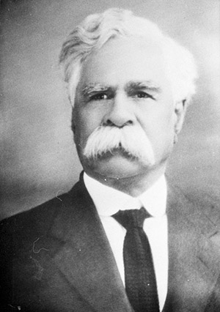

Yorta Yorta Elder William Cooper established the Australian Aborigines’ League (AAL) in 1934. The organisation called for an end to all forms of discrimination against Aboriginal people. One of the AAL’s main demands was for parliamentary representation. In 1932 Cooper began seeking signatures for a petition to the King requesting intervention for the betterment of Aboriginal people. He spent six years circulating the petition across Australia.
The finalised petition, presented to the government in 1937, held nearly 2,000 signatures. It asked that Aboriginal people be granted ‘representation in the Federal Parliament’ by ‘one of our own blood’ or by a white person ‘known to have studied our needs and to be in sympathy with our race’. The government under Prime Minister Lyons never sent the petition to the King. In 2014, Cooper’s grandson Uncle Alf “Boydie” Turner facilitated its presentation to Queen Elizabeth.

Joe Anderson
King Burraga (Joe Anderson) was a Dharawal man who lived along the Salt Pan Creek in New South Wales. Because his parents owned the land on which the family lived, it was an area not controlled by the Protection Board. The ‘Salt Pan Camp’ became a haven for those seeking to escape government control. King Burraga was one of the first Aboriginal people to use film as part of his activism. In 1933 he told a Cinesound production that ‘all the black man wants is representation in Federal Parliament.’

1940s

Sir Douglas Nicholls

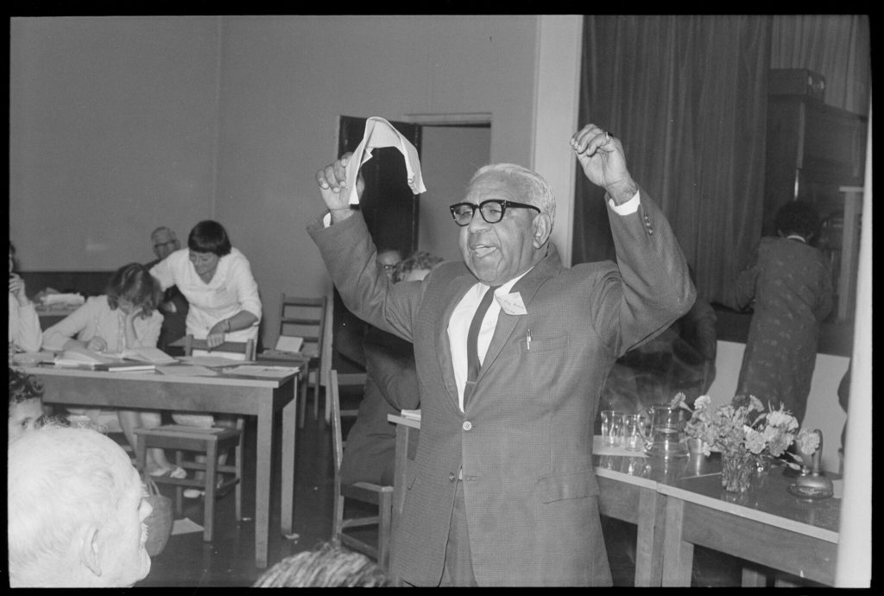

Yorta Yorta man Sir Doug Nicholls was a beloved footballer, soldier, pastor, and activist. As a mentee of William Cooper, Nicholls was a central figure of the Australian Aborigines’ League in Victoria. He was closely engaged in contemporary activism such as the Day of Mourning and the 1967 Referendum campaign. Nicholls went on to be a founding member of the Victorian Aborigines’ Advancement League and the Federal Council for the Advancement of Aboriginal and Torres Strait Islanders.
On 1 July 1949 Nicholls wrote to Prime Minister Chiefly seeking parliamentary representation of Aboriginal people and outlining how such a process might work:

I write to ask your support on behalf of my fellow members of the Australian Aboriginal race for our request that we be accorded representation in the Australian National Parliament.
The request is that provision should be made for the election to the House of Representatives of a representative of the Australian Aboriginal race to be elected upon the vote of all aborigines enrolled under the current Commonwealth franchise…
We feel that we are not asking more than the minimum to which we are entitled in requesting one spokesman for the native Australian race to sit in the Australian National Parliament.
–Sir Douglas Nicholls, Letter to the Prime Minister, 1 July 1949

While there have been Indigenous parliamentarians and Ministers for Aboriginal Affairs since the time of writing, there remains no person or body elected by Aboriginal voters for the purpose of representing Aboriginal interests.

Progress
From the late 1950s onwards, the focus of Aboriginal activism shifted to land rights. Key examples of such activism include the Yirrkala Bark Petitions and the campaign leading to the Mabo decision.
Multiple Aboriginal representative bodies have been established and subsequently disbanded, including the Federal Council for the Advancement of Aborigines and Torres Strait Islanders (FCATSI) and the Aboriginal and Torres Strait Islander Commission (ATSIC).
The Voice proposed by the Uluru Statement from the Heart was initially rejected by the Turnbull Government. In 2019 the Morrison Government initiated a co-design process with the formation of a Senior Advisory Committee co-chaired by Marcia Langton and Tom Calma. The Committee’s work is ongoing.

See also
Constitutional Recognition
Referendums in Australia

Reflection
I produced my Making History project on unceded Wurundjeri land. My Wikipedia-style article provides an overview of calls by First Nations activists for representation in the first half of the 20th Century. The purpose of my article was to contextualise public debate surrounding the introduction of a Constitutionally enshrined First Nations Voice to Parliament. This national conversation was sparked following the release of the Uluru Statement from the Heart in 2017, and heightened after the election of the Albanese government in mid-2022.
Having previously read Professor John Maynard’s work, I knew there is a relative scarcity of academic writing on First Nations’ activism in the early 20th Century, and what has been written is often kept behind a paywall. I chose to write a Wikipedia-style article because this format is synonymous with succinct, easily understandable information. Given there was no Wikipedia page dedicated to the topic, this was the appropriate format because it aligns with Wikipedia’s requirement that information shared on the website be “noteworthy”.
The main challenge I faced was scrutinising the concept of “reliable” and “authoritative” sources. At university the bastion of reliability is the peer reviewed academic journal. While I could find such content on some key figures such as Uncle William Cooper, there was little or no academic literature on other activists. This challenged me to closely examine my perspective on what constitutes “relatable” information. Ultimately I chose to include sources which were produced by or drew from the knowledge of First Nations people directly, even if the information was presented in a less formally academic format, such as a website.
I had to make editorial and ethical decisions about language. Firstly, I struggled to adopt the “neutral” language required by Wikipedia. To align with this policy I chose to use language such as “child removal“ instead of “forcibly removed” or “stolen”. Secondly, I decided to include out-dated language when quoting directly from First Nations activists. However, I included a content note so readers who did not feel comfortable with this type of language could choose to avoid it. I also placed a content note at the beginning of my article warning that the article contained images of First Nations people who have died. The simplest but most impactful ethical and editorial decision I made was to ensure that the majority of my sources were by First Nations authors.
January 2023, Philippines

About the Author
Madeleine Gome
Madeleine Gome is a history and law graduate currently working in the Victorian Government. Her Honours thesis examined the likelihood a referendum on a First Nations’ Voice to parliament would succeed. Madeleine enjoyed completing part of her studies in Norway and Hong Kong. She lives and works on Boon Wurrung and Wurundjeri Country.

Maynard, John (1997). “Fred Maynard and the Australian Aboriginal Progressive Association (AAPA): One God, One Aim, One Destiny”.
: 1.

Maynard, John (2003). “Vision, Voice and Influence: The Rise of the Australian Aboriginal Progressive Association”.
(121): 91.

Maynard, John (1997). “Fred Maynard and the Australian Aboriginal Progressive Association (AAPA): One God, One Aim, One Destiny”.
: 1-13.

Davis, Megan; Langton, Marcia (2016).
.

Maynard, John (1997). “Fred Maynard and the Australian Aboriginal Progressive Association (AAPA): One God, One Aim, One Destiny”.
: 1-3.

Maynard, Fred, 1927, [Letter to the Premier], NSW Premiers Department Correspondence Files, A27/915 in Maynard, John (1997). “Fred Maynard and the Australian Aboriginal Progressive Association (AAPA): One God, One Aim, One Destiny”.
: 9.

‘Shadrach Livingstone James’ (2021).
[website] https://www.firstpeoplesrelations.vic.gov.au/shadrach-livingstone-james. Accessed 28 April 2022.

James, Shadrach L. (24-03-1930). “Help my People!”.
In Attwood, Bain; Markus, Andrew (1990).

Darian-Smith, Eve (2013). Review of Barbara Miller,
.
193; Foster, Robert (2018). “Contested Destinies: Aboriginal Advocacy in South Australia’s Interwar Years”.
: 73.

Markus, Andrew (1983). “William Cooper and the 1937 Petition to the King”.
(1): 48, 55.

Markus, Andrew (1988).
Thorpe Clark, Mavis (1965).

Cooper, William (15-10-1933). “Petition to the King”.
In Attwood, Bain; and Markus, Andrew (1990).
.

Jacks, Timna (4-10-14). “Queen Accepts Petition for Aboriginal Rights, 80 Years on”.
Retrieved 2022-04-29. https://www.smh.com.au/politics/federal/queen-accepts-petition-for-aboriginal-rights-80-years-on-20141003-10ksh6.html.

‘The Burraga Story’,
[website]. Retrieved 2022-04-28. https://www.burraga.org/about.

NITV (2017). “King Burraga”.
[website]. Retrieved 2022-04-29. https://www.facebook.com/NITVAustralia/videos/10154771387477005/.

Thorpe Clark, Mavis (1965).

Broome, Richard. (2012).
. Retrieved 2022-04-29. https://adb.anu.edu.au/biography/nicholls-sir-douglas-ralph-doug-14920.

Nicholls, Doug (1949-07-01). Letter to Prime Minister Chifley, R Menzies and A Fadden. In Attwood, Bain; Markus, Andrew (1999).
.

IV

Chapter 5: Exhibition display
Utilising the exhibition format requires students to construct narratives in three dimensions and to understand how different audiences from differing backgrounds and abilities might encounter their displays. Rather than requiring a physical display, students prepare a proposal for an exhibition. This has the added appeal of allowing students to situate disparately located objects together in a hypothetical dialogue.
In this chapter you will find the following digital creations by student authors that exemplify the core qualities of this particular medium:
5.1 Fire Response in Bendigo

5

5.1 Fire Response in Bendigo
Jose Manga
In the early hours of August 26th 1871, the city of Sandhurst (now Bendigo) woke up to the sound of the fire tower’s bells and dense smoke coming from a fire that had broken out at the Beehive Building in the city centre. Located on Bendigo’s main street, the Beehive is an iconic building that in the nineteenth century was the commercial hub of the city, surrounded by the most important colonial government buildings, banks, offices, and storehouses. That morning, the fire threatened to consume the resources that had sustained the growth of the city and, in many ways, the success of the colonies. The fire was a reminder of the severe conditions in which these emergent societies had chosen to establish. In Australia, fire events caused by extreme weather have defined the natural landscapes and have shaped human interaction with the environment.
Fire is an essential natural element for all living creatures. It would be impossible to conceive human development without fire. However, fire is usually seen as a threat and a devastating event. Local Aboriginal peoples learnt to live with this phenomenon, successfully adapting to the varying nature of fires throughout millennia. With the arrival of European settlers, the pristine landscape suffered a dramatic change. Pastoralist settlers cleared vast forest areas and established cattle stations in the country. These enterprises were the starting point to the formation of colonial villages and towns. By the mid-19th century, these settlements were growing in size and population, as new waves of migrants moved to the bush, attracted to the land opportunities.
The discovery of gold in Victoria and New South Wales in the 1850’s not only transformed the landscape of rural Australia, but also brought enormous wealth and development to the emerging cities. Bendigo became one of the richest cities in the world thanks to its vast mineral resources. The Victorian gold rush would have a big effect on the way people responded to disastrous events. In order to respond to these urgent issues, the first Bendigo fire brigades were formed in 1855, with the purpose of protecting the city and the wealth produced in the area.
The Beehive Building fire exposed the risks of settling on a region that is surrounded by a dense forest that could prove fatal during the harsh summer season. But more importantly, the fire exposed the settler’s lack of preparedness against new environmental challenges. Days after the fire, a local resident wrote to the Bendigo Advertiser: “…our gallant band of firemen worked with a good will, but in an unfortunate way. Much of their vigorous exertion resulted in helpless confusion; but what could you expect when all gave orders, and each followed his own.” At the fire scene, the valiant efforts of the volunteers were countered by the evident lack of organisation. For the colonial authorities, it became clear that rural communities had much to learn from the environmental conditions in which they lived, and the way communities organised themselves in order to respond to these adverse situations.
The selection of objects displayed on ‘Fire Response in Bendigo’ show the evolution of the fire threat and the local response to these events in the Bendigo area. The chronological sequence starts with an acknowledgement of the relation between First Nations people, nature, and fire; followed by the establishment and development of the Bendigo Volunteer Fire Brigade throughout the twentieth century. This display is an invitation to reflect about the growth of Australia as a nation, the relationship of the Australian people with their environment, and the formation of an Australian rural identity.

An interactive H5P element has been excluded from this version of the text. You can view it online here:
https://oercollective.caul.edu.au/making-public-histories/?p=334#h5p-1

To view in full screen, click the maximize button in top right corner of the H5P window.

Reflection
The idea for this project came after a history article was published in the Bendigo Advertiser in July 2021. The article described a fire event that destroyed an emblematic building in the Bendigo city centre in August 1871. However, the focus of the article wasn’t on the fire event itself, but on the performance and the behaviour of the firefighters.
As a volunteer firefighter for nearly twenty years, I wanted to know more about the history of the local fire services. I joined the Bendigo Fire Brigade (BFB) in 2015, and in 2021 I was involved in the development of a small cataloguing project with the support of the brigade. We met regularly to register photos, artworks, documents, historical equipment, and memorabilia acquired by the brigade throughout the years. This project highlighted the importance of the brigade’s historical heritage. Volunteers understood that the cataloguing project went beyond preserving the objects, it was about preserving our identity as a brigade.
I also worked as a tour guide for more than sixteen years in Peru. During this time, I regularly visited museums, galleries, and archaeological sites. This activity gave me a better understanding of the important role of museums, not only as tourist attractions, but also as places where people reconnect with the past, and where community identity is developed. There is a strong connection between the exhibited objects and the viewer, and museums facilitate that connection providing neutral spaces where identities converge.
The exhibit project uses six objects arranged chronologically in the form of a timeline. The display tells the history of the response to fires, focusing on the creation and development of local fire brigades, and different historical episodes that had an influence on the local fire services.
The first object is a Bottlebrush (Callistemon spp.). This plant is endemic to Australia and is part of the natural landscape. This object acknowledges the connection between First Nations people, the landscape, natural events, and how people learnt and adapted to the challenges of the environment.
The second object is a hand-coloured photo from 1857. It shows the visit of Victorian Governor Henry Barkly to Bendigo. The Victorian gold rush had transformed the landscape of Bendigo (known as Sandhurst in those years). As the city grew, the emerging community and colonial authorities worked together in the formation of fire brigades, as a response to the urgent necessity to protect the lives and the assets of their citizens.
The third object is a smoke protector mask from 1875. This modern device was purchased and used by the newly formed Bendigo Fire Brigade in 1899. Towards the end of the 19th century, technological innovations were essential for the different productive activities in the colonies. Authorities realised that firefighting was an extremely dangerous activity and that they needed to acquire adequate protective gear for the volunteers.
The fourth object is a roll of honour with the names of the BFB members who served in the armed forces during the Great War. This object acknowledges the impact of the world wars on rural towns, and how these events helped in the construction of a new emerging Australian identity.
The fifth object is a photograph from 1963. The picture shows six members of the BFB running team that represented the brigade in competitions around the state. The post-war era was a time for the consolidation of the fire services within rural communities around the state and nationwide.
The last object is a modern thermal imaging camera used by fire crews in search and rescue operations. This device uses infrared radiation to capture temperature variations, and translates them into coloured images. For the display, the object faces the viewer, while connected to a small screen. The viewer can see the device as well as their own thermal image on the screen.
In this way, the display starts with an organic object that is a potential threat during the fire season, and finishes with an electronic device that captures the viewer’s own temperature.
The newspaper article that motivated me to do this project tackled some issues that perhaps not everyone is aware of. During the events of the 1871 fire, internal conflicts among members, lack of professionalism, and even social issues (like alcohol consumption) had a serious impact on the fire response. Over the years, volunteer brigades have developed and become professional institutions. However, there are still problems affecting the operational activities and the institutional image of the brigades. Political interference, lack of cultural and gender diversity, and a decrease of volunteer participation are some of the issues affecting the fire services these days. In many ways, the history of the Bendigo Fire Brigade is reflected on the history of rural Australia.
Lima, November 2022.

About the Author
Jose Manga
Jose Manga was born and raised in Peru where he worked in the cultural tourism sector for sixteen years, before migrating to Australia in 2014. In 2018, Jose started his studies at La Trobe University, graduating in 2021 as a Bachelor of Arts, majoring in History. He lives in Bendigo, Victoria, and currently works at the Bendigo Art Gallery. Jose plans to further his studies in the Museums and Cultural Heritage field. Jose has also been a volunteer firefighter in Peru and Australia for more than twenty years.

V

Chapter 6: Plan your research for publishing public history
This chapter is based on resources I created to support students in HIS3MHI from around 2016 to 2023 while working as a librarian at La Trobe University by day and my experiences volunteering at the Australian Queer Archives (AQuA) around the same time. Supporting La Trobe University History academics and students and volunteering with the AQuA have both significantly changed the way I think about and support history, research, and open education and scholarship. At the AQuA, we preserve and make research and more knowledge available for and with LGBTIQA+ communities within and beyond the academy in multiple formats (from queer history walks and exhibitions to an Honours thesis prize and beyond). Our collection and work may not be open in traditional academic “Open Access” ways, and it is not safe for our collection to be completely open to all, but we are open in the inclusive sense of the word. La Trobe University History academics similarly make history knowledge open and accessible beyond the academy in diverse ways (from heritage reports, policy and podcasts to history talks, television and beyond). They have both helped me see that research can be collective, generative, and transformative and I hope this chapter helps others see and advocate for this too. I have used some examples from my experiences supporting and doing queer and trans history to help contextualise the advice and activities in this chapter.

6

6.1 Plan your research
In Making History you are tasked with producing a major research project. The process of researching and presenting your work is a key part of how you connect with the ‘history industry’, as Paul Ashton and Paula Hamilton have termed it. Unpacking recent developments within this field, including in the Gallery, Library, Archive and Museum (GLAM) sector, becomes another valuable avenue for you to witness public history in action. This chapter provides key background to these developments, while also mapping out useful research activities (via H5P) that you can work through during your research process. If you record your reflections within these activities, you can download them as a document at the end of each one. Many of the research activities are contextualised with examples you can learn from and apply to your own topic. You can also find inspiration in the examples of past student projects and reflections in this book.
This chapter explores the different approaches GLAM sector institutions take when expanding access to their collections to help you navigate copyright, Creative Commons licenses and more access considerations for your public history projects. All have relatively recently started doing work with First Nations communities to navigate their important additional access, cultural safety, and sharing considerations. Archives often have additional privacy concerns to consider when deciding what can be made openly available.
Some key points to remember when planning and doing archival research:
- Think about who might have created records on your topic (people, organisations, government departments, and so on)
- Identify and use the language they might have used in the time and place you’re researching.
- Record your search strategies and citations as you go.
- Draw on multiple sources and perspectives.
- Look out for finding aids, research guides, reports and/or fact sheets related to your topic produced by librarians, archivists, or historians.
- Browse the collection or start broad and filter down.
- Think critically about what systemic racism, sexism, homophobia, transphobia that determined what histories are preserved and the gaps and biases in archives – and about decisions made around what records are digitised.
- Remember that not everything is online (and not everything should be) and that even if something is available online that does not mean you can use it in published work without asking permission.

7

6.2 Choose and refine your research topic
When deciding on and developing your topic, you should consider:
- Assessment requirements
- Identify the general/broad topic
- Initial research
- Consider the scope of your topic
- Draft a research question
- Further research/refine your question
Find more tips in Developing a research question Achieve @ Uni.

Activity: Brainstorm keywords and more details for your topic
Work your way through the examples and activities in the following module to help you plan and record your research:

An interactive H5P element has been excluded from this version of the text. You can view it online here:
https://oercollective.caul.edu.au/making-public-histories/?p=349#h5p-2

8

6.3 Navigate Copyright, Creative Commons, and the Continuum of Openness Online
Gaining knowledge about and experience navigating copyright, public domain, Creative Commons and more access complexities and considerations will be extremely helpful for your digital history projects if you wish to share them beyond this subject and make history as a historian or GLAM sector professional.
It is very important to think early on about what records are likely to be available for you to use online and what ones might not be available as this will help you determine your project topic, scope, and format. Copyright is one of the main considerations that determine what is available online, but other very important considerations include: privacy, cultural sensitivity, accessibility, and project priorities, funding, or sponsorship.
Watch this short (approximately 10 minute) presentation from Sari Braithwaite – a historian by day and filmmaker by night – on how she has creatively, courageously, and carefully navigated copyright considerations as a historian and creator:

One or more interactive elements has been excluded from this version of the text. You can view them online here: https://oercollective.caul.edu.au/making-public-histories/?p=352#oembed-1

In this essay How to think left on copyright, Lizzie O’Shea illustrates the limits of Copyright law in Australia and beyond. O’Shea argues that it tends to help big publishers and corporations more than individual or community creators. She highlights the power and potential of Creative Commons and other licenses as alternatives that give creators more control over how their intellectual property can be used.

Creative Commons licenses
In Australia, there are six standard licenses, each permitting material to be used in a different way.
Read the following to find out more about Creative Commons from the Creative Commons website.
Watch this short video on Creative Commons licenses to help you understand them more:

One or more interactive elements has been excluded from this version of the text. You can view them online here: https://oercollective.caul.edu.au/making-public-histories/?p=352#oembed-2

This Creative Commons License spectrum provides a visual representation of the different licenses and how you can use content which uses these licenses along a continuum of openness:

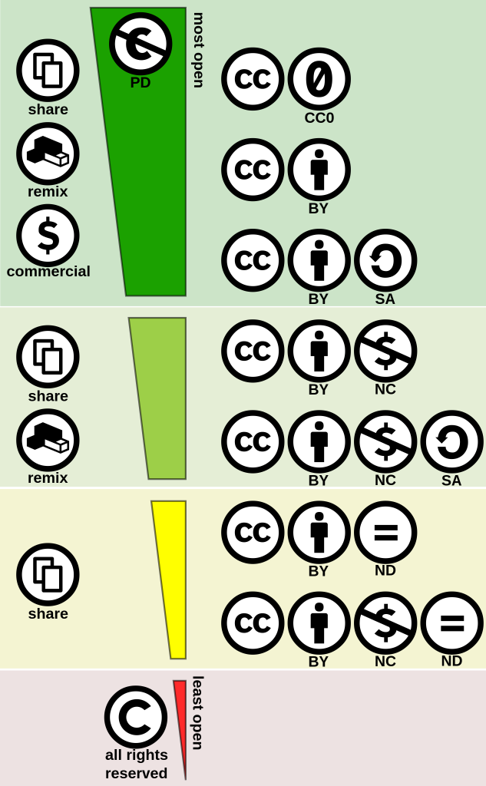

by Shaddim from
used under
.
Public Domain material is the most open and has the least restrictions on how you can use it. Check out the Australian Copyright Council Factsheet: Duration of Copyright to find out when material enters the Public Domain as this may help you choose a research topic and plan your research – for example: you may want to select a time where you know public domain material should be easily accessible online. If something is in the public domain, it states: “Public domain” or “No rights reserved” or “CCO”.
If you decide not to publish your work, you can use more material for private research or study under fair dealing. Find out more about Fair dealing in the Fair Dealing: What Can I Use Without Permission – ACC – INFO079 fact sheet by the Australian Copyright Council.
Libraries and archives in Australia frequently stress that digitising material does not change the copyright status of material. In fact, several have adapted the following statement in response to the question Do I need the Library’s permission as well as the copyright owner’s permission? from the National Library of Australia, so it is a good one to be familiar with.

Activity: Quick Creative Commons and Public Domain image searching
These activities will help increase your familiarity with Creative Commons and Public Domain image searching and give you a broad idea about what is out there on your topic that you can use in published work.
You will need to dig deeper in the archives, but these sources covered are good starting points for your research and what you find (or do not find) here may help you decide on the scope and/or format of your search project.
Record links and information about the images you’ve found as you go through it and download as a document after you complete it.
You may find it helpful to use Deakin University Library’s Creative Commons Attribution Builder to learn how to appropriately attribute any images you use.

9

6.4 Contextualise collections by considering cultural sensitivity and privacy
Cultural sensitivity, safety and privacy are important ethical considerations connected to but distinct from copyright to keep in mind when working with collections. The digital environment brings great power and potential for expanding access to collections, but with this power comes great responsibility and risk.
In Open as in dangerous, Chris Bourg warns that one potential danger is that providing open access to collections can potentially lead to a loss of local, personal context particularly where it involves making tacit, embodied knowledge more formal and therefore disembodied that is then extracted and shared in diverse ways without consent. Similarly, in Does Information really want to be free? Indigenous knowledge systems and the question of openness, Kimberley A Christen argues that information wants to be contextualised rather than ‘free’ through different kinds of licenses and a complex, community-driven content management system. Kirsten Thorpe and colleagues have been doing related work adapting this content management system at the State Library of New South Wales and beyond. Find out more about Kirsten Thorpe’s work in Speaking back to colonial collections: Building living Aboriginal archives. In Sacred data, Jazz Money provides a powerful introduction to Indigenous data sovereignty and the many legal and ethical dimensions around collections, research and policy data storage, ownership, access, consent as well as intellectual property in the digital environment.
See this Indigenous Cultural and Intellectual Property (ICIP) Information Sheet from Arts Law for further information.

10

6.5 Publish your work
If you would like to publish your project and share it with people and communities you have done research with or about, you must pay close attention to copyright and access considerations from the planning stage. If you do not want to publish your work, you can use additional material for private study or research under the fair dealing rule in Australian Copyright law. Copyright and access considerations may help you determine the format that is right for you and your audience. If you are finding copyright, Creative Commons and access restrictions too limiting and/or confusing for your topic, think about how the format you choose might enable you to tell histories without reproducing images, audio or film or otherwise breaching copyright, cultural sensitivity, or privacy. Think about the format that might be most accessible to and appropriate for the communities connected to your research. If you can, ask those communities what format they would like rather than assume you know what is best. If you cannot ask them directly, you can do some research to see if you can find examples of history projects led by those communities.
For example:
- Wikipedia articles use existing online sources to construct biographies and topic entries without requiring archival access.
- Podcasts enable you to describe visual sources rather than reproduce them and will also enable you to protect privacy, avoid deadnaming or misgendering people, and minimise risk of collections used in your research being decontextualised.
- Museum displays and illustrated essays might enable you to tell a story based on a selection of objects that you are permitted to share under Copyright and Creative Commons provisions.
Another publishing consideration you need to make is to decide on the Creative Commons licence you want to use.

Activity: Interactive licensing tool
Use the following Licensing choices tool to help you decide on the Creative Commons license that works best for your project:

One or more interactive elements has been excluded from this version of the text. You can view them online here: https://oercollective.caul.edu.au/making-public-histories/?p=356

This Licensing choices tool contains elements of the CC License Chooser (beta) by The University of Newcastle is licensed under Attribution 4.0 International (CC BY 4.0) and elements of the CC licensing flowchart by Creative Commons Australia licensed under Attribution 2.5 Generic (CC BY 2.5).
Note that some collections may specify the kind of license you can use if you want to use those collections without asking permission. For example, see Copyright and permissions | British Museum.
Read the following blog posts from people who changed their Creative Commons licenses to more open ones if you need help deciding on a Creative Commons license that may work for your research project:
- why, oh why, CC-BY? – Bethany Nowviskie
- Creative Commons, Open Access, and hypocrisy

11

6.6 Dig deeper in the archives
The first thing to think about when digging deeper in the archives is who might have created records on your topic as this will help you determine where to look.

Community collections
Community archives and other collections provide an important antidote to silences and absences in mainstream government and media collections. They collect, describe, and share communities’ histories in their own words.
- Victorian Collections – a gateway to community GLAM collections, including some of those from the Australian Queer Archives, many multicultural heritage groups and RSLs, and so much more. See their reuse and more policies.
- Collections NSW– Collections of objects and photographs from regional areas in NSW.
- Living Histories at Newcastle -Collections from the University of Newcastle and community history groups in Newcastle
- Reason in Revolt: This database contains digitised primary source documents of Australian radicalism. We recommend browsing by events, institutions, people, places, and subjects. These sources are primarily licensed under Creative Commons Attribution-Non-commercial-No Derivative Works 3.0 Australia License. There are some exceptions to this license on the platform, so always check the collection item you want to use.
- Digital Transgender Archive – search across a variety of collections related to trans history. Check out their comprehensive and thoughtful copyright, privacy and takedown policy and more policies.

Government archives
Government libraries and archives are often a traditional starting point for archival research and may have useful perspectives, but they represent dominant values at the time the materials were collected.
Remember to think critically about what systemic racism, sexism, homophobia, transphobia that determined what histories are preserved and the gaps and biases in these collections and about decisions around what records are digitised and how they are described.
Try to find personal and community-led histories to complement this government perspective.
One of the first things to think about is which level of government (local, state, or federal) is most likely to have been involved in creating records about this topic. This determines where the records are stored. There is some overlap of responsibility and funding for most Federal and State government issues, so you may need to check both Federal and State-based Libraries and Archives.
- Australian archival research guide – Public records page: Find and use Australian records and archives online and at the library.
- Public Records Office of Victoria (PROV): Divorce records, Criminal/Court records, Prison records, Health records and Education records. See Copyright for researchers | PROV.
- National Archives of Australia : Records of defence/war, migration and citizenship, and security and intelligence. See Copyright | naa.gov.au.
Local governments work with local communities, including around local history, arts, culture, parks, recreation, environment, and sustainability and beyond. Local libraries are increasingly supporting digital history projects, so if you are interested in histories related to a particular place, the local library could be a good starting point.

Querying Trove
Trove is a platform you can use to search across multiple library collections in Australia. It is particularly well known for its digitised newspaper collection.
News search tips
- Use the names of people involved.
- Try to think of your topic in media language used at a particular time (different publications may use different language just as they do today).
- You need to use the terms /language used at time.
- Note that many traditional, mainstream media sources have a history of not reporting, under-reporting and/or misrepresenting race, gender, and sexuality, so you will often need to think creatively about the language used and even look beyond them to compare with alternative news sources. We have provided some alternatives for you on this page.
- Compare reporting in broadsheets (e.g., the Age) to tabloids (e.g., Truth).
- Restrict the search to the approximate date of a particular incident or refine a simple search by Decade to see the historical specificity of a term or issue.
If you have not used Trove before or need a refresher, watch this quick guide to Trove Newspapers search:
Trove Tip | Trove Newspapers Search
If you would like to dig deeper in Trove newspapers, you can watch this webinar on Trove’s newspapers:
Webinar: Discover Trove’s Newspapers – July 22, 2020

Activity: Browsing and querying community collections, government collections and Trove

12

6.7 Conclusion
In this chapter planning your research has been situated within Australia’s public history industry to demonstrate that the work you do at university has the potential to reach beyond it, and to highlight the important role you play as the historian making public histories.
The skills presented in this chapter will help you record and build on your searching, ensure you have checked a range of databases, navigate the complexities of copyright, Creative Commons and more access and sharing sensitivities, restrictions and requirements, and attribute collection items you use in your project. Your audience and the access and sharing sensitivities, restrictions and requirements on the material you find will help you decide what license and format will be most appropriate to use when publishing your research beyond the university.

1

Further reading
Ann Curthoys and Ann McGrath, How to Write History That People Want to Read (Sydney: UNSW Press, 2009), 1-12.
Tony Birch, ‘If we are to recognise heroes, where are the stories of Aboriginal courage?’, Guardian, 8 September 2017.
Maria Nugent & Gaye Sculthorpe, ‘A Shield Loaded with History: Encounters, Objects and Exhibitions,’ Australian Historical Studies 49, no.1 (2018), 28-43
Matilda Keynes, “History Education for Transitional Justice? Challenges, Limitations and Possibilities for Settler Colonial Australia.” The International Journal of Transitional Justice 13, no. 1 (2019): 113-33. https://doi.org/10.1093/ijtj/ijy026.
Natalie Harkin ‘Weaving the Colonial Archive: A Basket to Lighten the Load’, Journal of Australian Studies 44, no. 2 (2020), 154-66.
Clare Wright, ‘Sex, Lies and History on TV’, Australian History Now, ed. Anna Clark and Paul Ashton (NewSouth, 2013).
Elizabeth Pente, Paul Ward, Milton Brown and Hardeep Sahota, ‘The co-production of historical knowledge: Implications for the history of identities, Identity Papers: A Journal of British and Irish Studies 1, No. 1 (2015), 32-53.
Andrew Flinn, ‘Independent Community Archives and Community-Generated Content: Writing, Saving and Sharing Our Histories,’ Convergence 16, no. 1 (2010), 39-51.
Clare Crowe, Helen Morgan and Mary Tomsic, ‘Women, History and Wikipedia Editing,’ Agora 56:1 (2021), 50–53
Eleanor Casella and Conlin Fennelly, ‘Ghosts of Sorrow, Sin and Crime: Dark Tourism and Convict Heritage in Van Diemen’s Land, Australia,’ International Journal of Historical Archaeology 20, no. 3 (2016), 506-20.

2

Versioning History
This page provides a record of changes made to this textbook. Each set of edits is acknowledged with a 0.01 increase in the version number. The exported files for this toolkit reflect the most recent version.
If you find an error, please contact eBureau@latrobe.edu.au
Version | Date | Change | Details
0.9 (beta version) | 29/03/23 | Beta version of the book made available to 2023 Making History students. | Beta version made available to 2023 Making History students to support assessment work in Semester 1. These experiences and feedback will inform v1.0.
1.0 | 07/09/23 | First edition published

3

Review Statement
La Trobe eBureau open publications rely on mechanisms to ensure that they are high quality, and meet the needs of all students and educators. This takes the form of double peer review.

Peer review
Two rounds of peer review were completed for this publication on 20/06/2023 by:
- Michael A. McDonnell, The University of Sydney
- Caroline Wallace, La Trobe University
The peer review was structured around considerations of the intended audience of the book, and examined the comprehensiveness, accuracy, and relevance of content, as well as longevity and cultural relevance.
Changes suggested by the editor and reviewers were incorporated by the author in consultation with the publisher.
The authors would like to thank the reviewers for the time, care, and commitment they contributed to the project. We recognise that peer reviewing is a generous act of service on their part. This book would not be the robust, valuable resource that it is were it not for their feedback and input.

