Time Budget – (Course name)

Week | HOURS OF STUDY
 | 1 |  | 2 |  | 3 | 4 | 5 | 6 | 7 | 8 | 9 | 10
1  2/3 | Sample online activities (add detail) |  |  |  |  |  | Sample online activities | Sample book work | Sample Lecture | Sample Assessment | Sample online activities | Sample virtual classroom |  | 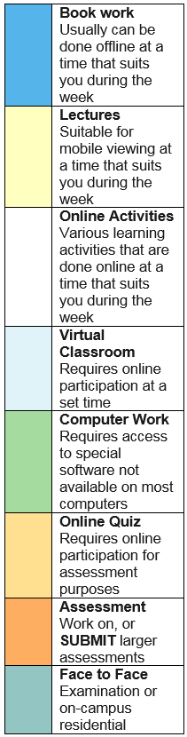
2
9/3
3
16/3
4
23/3
5
30/3
6
6/4
7
13/4
8
20/4
9
27/4
10
4/5
11
11/5
12
18/5
13
25/5
- Summary of work to be completed/submitted for this subject
End of Week … | Date | Details
2
4
5
6
7
9
10
13

