Locating an article’s copyright licence

An article’s copyright licence can be hard to find. It may be located in an article’s footnotes, near the author biography or in the reference list.

Sometimes there is a [licence icon/button](https://commons.wikimedia.org/wiki/File:Open_Content_A_Practical_Guide_to_Using_Creative_Commons_Licences_web-29.png) or a statement such as: “This work is licensed under the Creative Commons Attribution International licence (CC BY 4.0)”. This may not appear on the web version of the article but only on the PDF.

For example, this [article record](https://www.oalib.com/research/6821923) in the *Open Access Library Journal* does not display an obvious copyright licence. It is only visible when the PDF version is viewed.

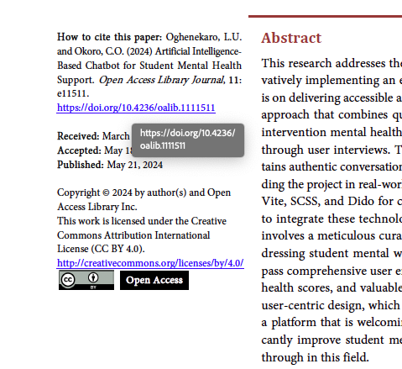

Another problem with journal articles is that they may be free to read but not free to republish. For example, [this article from the British Medical Journal](https://www.bmj.com/content/385/bmj.q1153?_gl=1*wolak9*_up*MQ..&gclid=CjwKCAjwmYCzBhA6EiwAxFwfgFVuBZ14rEgnMs0CKZ1opOp3wonRXuxyuLh5JHgkn60FIlJADqoGdRoCF30QAvD_BwE) can be read in full text, but it is not a Creative Commons licensed article. There is no licence on it and no clear information about how to use the article's contents other than reading it.

To request permission to reuse the article, click on the article’s ‘request permissions’ link, and you will be directed to the [Copyright Clearance Centre,](https://s100.copyright.com/AppDispatchServlet?publisherName=BMJ&publication=bmj&title=Tobacco%20funded%20research%3A%20how%20even%20journals%20with%20bans%20find%20it%20hard%20to%20stem%20the%20tide%20of%20publications&publicationDate=05/30/2024&author=Irene%20van%20den%20Berg%2C%20Mathilde%20de%20Jeu%2C%20Hristio%20Boytchev&contentID=10.1136/bmj.q1153&volumeNum=385&issueNum=&startPage=&endPage=&copyright=BMJ%20Publishing%20Group%20Ltd&oa=n&orderBeanReset=1&link_type=PERMISSIONDIRECT&atom=/bmj/385/bmj.q1153.atom) a copyright permissions service. They usually charge for permissions unless you are the author of the article.